Cardiovascular risk assessment in people living with HIV compared to the general population

Benoît Delabays1, Matthias Cavassini2, Jose Damas Fernandez2, Hadrien Beuret1, Alexandra Calmy3, Barbara Hasse4, Heiner C. Bucher5, Manuel Frischknecht6, Olivier Müller7, Marie Méan1, Peter Vollenweider1, *Pedro Marques-Vidal1 and *Julien Vaucher1

* Co-last authors

1 Department of Medicine, Division of Internal Medicine, Lausanne University Hospital and University of Lausanne, Lausanne, Switzerland

2 Department of Medicine, Division of Infectious Diseases, Lausanne University Hospital and University of Lausanne, Lausanne, Switzerland

3 Division of Infectious Diseases, Geneva University Hospital, Geneva, Switzerland

4 Department of Infectious Diseases and Hospital Epidemiology, Zürich University Hospital, Zürich, Switzerland

5 Basel Institute for Clinical Epidemiology & Biostatistics, Basel University Hospital, Basel, Switzerland

6 Division of Infectious Diseases and Hospital Epidemiology, Cantonal Hospital St. Gallen, St. Gallen, Switzerland

7 Heart and Vessel Department, Division of Cardiology, Lausanne University Hospital and University of Lausanne, Lausanne, Switzerland

**Supplementary material**

Contents

**Exclusion criteria** 3

**Recalibration of the Pooled Cohort Equations** 4

**Supplementary tables** 5

**Supplementary figures** 30

**References** 44

# **Exclusion criteria**

We used the following exclusion criteria for both cohorts:

* Ethnicities other than Caucasian or African.
* Individuals with a history of previous atherosclerotic cardiovascular disease (ASCVD), defined as a personal history of acute myocardial infarction, stroke or transient ischemic attack, symptomatic coronary artery disease (stenosis >50% treated by percutaneous coronary intervention or coronary artery bypass graft).

In the SHCS:

* Individuals aged under 18 years.
* Infection with HIV type 2 or unknown virus subtype.
* Individuals who died or were lost to follow-up before 1st January 2003.
* Individuals enrolled after 31th December 2009.

In the CoLaus|PsyCoLaus study:

* Individuals with a known HIV infection.

# **Recalibration of the Pooled Cohort Equations**

**Originally published coefficients of ACC/AHA risk score.1**

|  |  |  |  |  |
| --- | --- | --- | --- | --- |
|  | Caucasian women | Caucasian men | Afro-American women | Afro-American men |
| Ln Age (years) | -29.799 | 12.344 | 17.114 | 2.469 |
| Ln Total Cholesterol (mg/dL) | 13.54 | 11.853 | -18.920 | 0.302 |
| Ln HDL Cholesterol (mg/dL) | -13.578 | -7.99 | 4.475 | -0.307 |
| Current Smoker (1=yes, 0=no) | 7.574 | 7.837 | 0.691 | 0.549 |
| Diabetes (1=yes, 0=no) | 0.661 | 0.658 | 0.874 | 0.645 |
| Ln Age x Ln Total Cholesterol | -3.114 | -2.664 | - | - |
| Ln Age x Ln HDL Cholesterol | 3.149 | 1.769 | - | - |
| Ln Untreated SBP (mm Hg) | 1.957 | 1.764 | 27.820 | 1.809 |
| Ln Treated SBP (mm Hg) | 2.019 | 1.797 | 29.291 | 1.916 |
| Ln Age x Current Smoker | -1.665 | -1.795 | - | - |
| Population mean | -29.18 | 61.18 | 86.61 | 19.54 |
| Baseline Survival at 10 years | 0.9665 | 0.9144 | 0.9533 | 0.8954 |

**Calculation of ASCVD 10-year risk for Swiss population with and without recalibration of ACC/AHA risk score.2**

ASCVD risk by original ACC/AHA risk equations:

$$10 year risk of ASCVD={1-Baseline Survival at 10 years}^{\exp\left(Riskscore-Population mean\right)}$$

ASCVD risk using the recalibrated ACC/AHA risk equations:

$$Correction factor=ln\left(\frac{\frac{observed event frequency}{1-observed event frequency }}{\frac{mean predicted risk}{1-predicted risk }}\right)=ln\left(\frac{\frac{0.069220803}{0.930779197 }}{\frac{0.0688847}{0.9311153 }}\right)=0.00522838$$

$$10 year risk of ASCVD{=1-Baseline Survival at 10 years}^{exp(Riskscore-Population mean-0.00522838)}$$

Abbreviations: ACC, American College of Cardiology; AHA, American Heart Association; ASCVD, atherosclerotic cardiovascular disease.

# **Supplementary tables**

**Supplementary table 1.** Characteristics of the risk algorithms used in the present study.

|  |  |
| --- | --- |
| **ESC SCORE2 and SCORE-OP** |  |
| Included variables | Age, Sex, Geographical information (4 European risk regions), TC, HDL-C, SBP, DM, Smoking status |
| Predicted outcome | 10 year risk of fatal CVD, nonfatal myocardial infarction, and nonfatal stroke |
| Age range | SCORE2: 40-69 years; SCORE-OP: ≥70 years |
| Derivation sample and size | SCORE2: 45 prospective studies from 13 European countries (677,684 persons, 376,949 women)  SCORE-OP: 1 prospective study (28,503 persons, 14,252 women) |
| Baseline of data | SCORE2: 1990-2009 (first published 2021), SCORE-OP 1994-2003 (first published 2021) |
| Website | https://www.escardio.org/Education/Practice-Tools/CVD-prevention-toolbox/SCORE-Risk-Charts |
| **AHA/ACC PCE** |  |
| Included variables | Age, Sex, Ethnicity, TC, HDL-C, SBP, DM, Smoking status |
| Predicted outcome | 10 year risk of fatal CHD, nonfatal myocardial infarction, and fatal or nonfatal stroke |
| Age range | 40-79 years |
| Derivation sample and size | 6 prospective studies from the U.S.A (26,689 persons, 14,984 women, 7,835 African-American individuals) |
| Baseline of data | 1971-2000 (first published 2013) |
| Website | https://tools.acc.org/ASCVD-Risk-Estimator-Plus/#!/calculate/estimate/ |
| **D:A:D** |  |
| Included variables | Age, Sex, SBP, Smoking status, Family history of CVD, DM, TC, HDL-C, time exposure to protease inhibitors, Abacavir exposure, CD4 T cells count |
| Predicted outcome | 5 year risk of fatal CHD, nonfatal MI, stroke or invasive coronary artery procedure (including coronary artery by-pass or angioplasty and carotid artery endarterectomy) |
| Age range | 18-75 years |
| Derivation sample and size | 11 prospective studies from 20 countries in Europe and Australia (22,625 HIV-infected persons, 5,860 women) |
| Baseline of data | 2000-2001 (first published 2010, updated 2016) |
| Website | <https://chip.dk/Tools-Standards/Clinical-risk-scores> |

Abbreviations: ACC, American College of Cardiology; AHA, American Heart Association; CVD, Cardiovascular disease (coronary heart disease, heart failure, stroke, and sudden death); CHD, coronary heart disease; D:A:D, Data collection on Adverse Effects of Anti-HIV Drugs; DM, Diabetes mellitus; ESC, European Society of Cardiology; HDL-C, high-density lipoprotein cholesterol; MI, myocardial infarction; PCE, Pooled Cohort Equations; SBP, systolic blood pressure; SCORE2, Systematic Coronary Risk Evaluation 2; SCORE-OP, Systematic Coronary Risk Evaluation in Older Persons; TC, total cholesterol.

**Supplementary table 2.** Distribution of risk categories in risk prediction model analysis, by incident cardiovascular events in SHCS and in CoLaus|PsyCoLaus study.

|  |  |  |  |  |  |  |
| --- | --- | --- | --- | --- | --- | --- |
|  | **SHCS** | |  | **CoLaus|PsyCoLaus Study** | |  |
|  | Incident ASCVD | |  | Incident ASCVD | |  |
|  | No | Yes | Total | No | Yes | Total |
| **ESC SCORE2 (10-year risk)** |  | |  |  | |  |
| *N* | 5840 | 533 | 6373 | 5029 | 374 | 5403 |
| Low to moderate**\*** (%) | 3684 (63.1) | 148 (27.8) | 3832 (60.1) | 3242 (64.5) | 90 (24.1) | 3332 (61.7) |
| High**\*** (%) | 1801 (30.4) | 265 (49.7) | 2066 (32.4) | 1363 (27.1) | 169 (45.2) | 1532 (28.4) |
| Very high**\*** (%) | 355 (6.1) | 120 (22.5) | 475 (7.5) | 424 (8.4) | 115 (30.8) | 539 (10) |
| **AHA/ACC PCE (10-year risk)** |  | |  |  | |  |
| *N* | 5840 | 533 | 6373 | 5029 | 374 | 5403 |
| Low (<5%) (%) | 4206 (72.0) | 177 (33.2) | 4383 (68.8) | 3064 (60.9) | 59 (15.8) | 3123 (57.8) |
| Borderline (5 to <7.5%) (%) | 541 (9.3) | 67 (12.6) | 608 (9.5) | 507 (10.1) | 31 (8.3) | 538 (10) |
| Intermediate (7.5 to <20%) (%) | 775 (13.3) | 169 (31.7) | 944 (14.8) | 921 (18.3) | 138 (36.9) | 1059 (19.6) |
| High (≥20%) (%) | 318 (5.5) | 120 (22.5) | 438 (6.9) | 537 (10.7) | 144 (39.0) | 683 (12.6) |
| **D:A:D (5-year risk)** |  | |  | N/A | | |
| *N* | 5840 | 533 | 6373 |
| Low (<1%) (%) | 2295 (39.3) | 35 (6.6) | 2330 (36.6) |
| Intermediate (1 to <5%) (%) | 2974 (50.9) | 313 (58.7) | 3287 (51.6) |
| High (5% to <10%) (%) | 431 (7.4) | 104 (19.5) | 535 (8.4) |
| Very high (≥10%) (%) | 140 (2.4) | 81 (15.2) | 221 (3.5) |

Percentages are expressed by columns. Percentages may not achieve 100% as values were rounded. SCORE2 includes SCORE-OP.

* Individuals aged less than 50 years: low-to-moderate (<2.5%), high (2.5-7.5%), very high (≥7.5%). Individuals aged 50 to 69 years: low-to-moderate (<5%), high (5-10%), very high (≥10%). Individuals aged 70 years or more: low-to-moderate (<7.5%), high (7.5-15%), very high (≥15%).

Abbreviations: ACC, American College of Cardiology; AHA, American Heart Association; ASCVD, atherosclerotic cardiovascular disease; ESC, European Society of Cardiology; N/A, not applicable; PCE, Pooled Cohort Equations; SCORE2, Systematic Coronary Risk Evaluation 2; D:A:D, Data collection on Adverse Effects of Anti-HIV Drugs.

**Supplementary table 3.** Incident ASCVD subtypes and cause of death in SHCS and CoLaus|PsyCoLaus study.

|  |  |  |
| --- | --- | --- |
|  | **SHCS (N=6373)** | **CoLaus|PsyCoLaus (N=5403)** |
| Acute myocardial infarction | 261 (4.1) | 112 (2.1) |
| Coronary heart disease | 100 (1.6) | 134 (2.5) |
| Acute ischemic stroke or TIA | 157 (2.5) | 123 (2.3) |
| Cardiovascular death | 59 (0.9) | 68 (1.3) |
| Non-cardiovascular death | 788 (12.4) | 309 (5.7) |

Results are expressed as number of participants (%). Percentages are expressed by column.

In the SHCS, 18 individuals had missing cause of death but were still included in the analysis as they experienced prior ASCVD. Participants experiencing an ASCVD were subsequently censored for the rest of the study period to prevent double-counting of participants facing additional ASCVD events.

Abbreviations: ASCVD, atherosclerotic cardiovascular disease; TIA, transient ischemic attack.

**Supplementary table 4.** ASCVD incidence rate according to age in SHCS and CoLaus|PsyCoLaus study.

|  |  |  |  |  |
| --- | --- | --- | --- | --- |
|  | **SHCS** | | **CoLaus|PsyCoLaus study** | |
| Age | Rate | 95% CI | Rate | 95% CI |
| <40 | **2.7** | 2.3 - 3.3 | **0.7** | 0.3 - 1.6 |
| 40-50 | **7.7** | 6.7 - 8.8 | **2.9** | 2.2 - 3.9 |
| 50-55 | **11.2** | 8.7 - 14.3 | **5.2** | 3.8 - 7.1 |
| 55-60 | **15.9** | 12.1 - 20.9 | **7.4** | 5.6 - 9.8 |
| 60-65 | **24** | 18 - 32 | **10.9** | 8.8 - 13.6 |
| >65 | **27.3** | 19.4 - 38.5 | **20.3** | 17.3 - 23.9 |
| Overall**\*** | **12.9** | 12.8 - 13 | **7.5** | 7.4 - 7.5 |

Rates are expressed per 1,000 person/year with SHCS follow-up of 86,303.9 persons/year and CoLaus|PsyCoLaus study: follow-up of 53,216.8 person/year.

**\*** Age standardization was based on the official statistics on the Swiss general population (Swiss Federal Statistical Office; <https://www.bfs.admin.ch>).

Abbreviations: ASCVD, atherosclerotic cardiovascular disease; CI, confidence interval.

**Supplementary table 5.** Individuals taking lipid-lowering drugs and reaching LDL-C targets, according to their categories of risk (ESC SCORE) and to 2016 ESC guidelines on the management of dyslipidemias, in SHCS and CoLaus|PsyCoLaus study.

|  |  |  |
| --- | --- | --- |
|  | **SHCS** | **CoLaus|PsyCoLaus study** |
| Low/intermediate risk with LDL-C<3.0mmol/l | 40.9% | 38.9% |
| High risk with LDL-C<2.6mmol/l | 11.1% | 26% |
| Very high risk with LDL-C<1.8mmol/l | 11% | 15.4% |

LDL-C targets were defined according to the 2016 ESC guidelines for the management of dyslipidemia3 and categorization of risk according to SCORE.

Abbreviations: ESC, European Society of Cardiology; LDL-C, low-density lipoprotein cholesterol; SCORE, Systematic Coronary Risk Evaluation.

**Supplementary table 6.** Performance of ESC SCORE2, AHA/ACC PCE and D:A:D scores to identify incident ASCVD (N=533 in SHCS; N=372 in CoLaus|PsyCoLaus).

|  |  |  |  |  |  |
| --- | --- | --- | --- | --- | --- |
|  | **SHCS** | | | **CoLaus|PsyCoLaus study** | |
|  | **ESC SCORE2** | **AHA/ACC PCE** | **D:A:D** | **ESC SCORE2** | **AHA/ACC PCE** |
| **Discrimination** |  |  |  |  |  |
| Sensitivity (%) (95% CI) | 72.2 (68.2 - 76) | 54.2 (49.9 - 58.5) | 34.7 (30.7 - 38.9) | 75.9 (71.3 – 80.2) | 75.9 (71.3 - 80.2) |
| Specificity (%) (95% CI) | 63.1 (61.8 - 64.3) | 81.3 (80.3 - 82.3) | 90.2 (89.4 - 91) | 64.5 (63.1 – 65.8) | 71.3 (70.1 - 72.6) |
| Positive predictive value (%) (95% CI) | 15.2 (13.8 – 16.6) | 20.9 (18.8 - 23.2) | 24.5 (21.4 - 27.7) | 13.7 (12.3 – 15.3) | 16.5 (14.7 - 18.3) |
| Negative predictive value (%) (95% CI) | 96.1 (95.5 – 96.7) | 95.1 (94.5 - 95.7) | 93.8 (93.1 - 94.4) | 97.3 (96.7 – 97.8) | 97.6 (97 - 98) |
| AUROC (95% CI) | 0.745 (0.723-0.767) | 0.757 (0.736-0.777) | 0.763 (0.743-0.783) | 0.800 (0.777-0.822) | 0.806 (0.784-0.827) |
| Youden’s index (95% CI) | 0.375 (0.336-0.415) | 0.391 (0.357-0.424) | 0.407 (0.370-0.444) | 0.471 (0.422-0.520) | 0.486 (0.441-0.532) |
| **Calibration** |  |  |  |  |  |
| Brier score | 0.0760 | 0.0725 | 0.0764 | 0.0610 | 0.0583 |
| Hosmer-Lemeshow test (p-value) | < 0.001 | < 0.001 | < 0.001 | < 0.001 | < 0.001 |
| **Model fit** |  |  |  |  |  |
| AIC | 8765 | 8690 | 8624 | 5867 | 5763 |
| BIC | 8778 | 8710 | 8645 | 5880 | 5783 |

All scores were dichotomized into low/intermediate versus high/very high categories of risk. There are no clinical cut-offs for the interpretation of the results.

Abbreviations: ACC, American College of Cardiology; AIC, Akaike information criterion; AHA, American Heart Association; ASCVD, atherosclerotic cardiovascular disease; AUROC, area under the receiver operating curve, BIC, Bayesian information criteria; CI, confidence interval; D:A:D, Data collection on Adverse Effects of Anti HIV Drugs; ESC, European Society of Cardiology; PCE, Pooled Cohort Equation; SCORE2, Systematic Coronary Risk Evaluation 2.

**Supplementary table 7.** Participants’ characteristics at baseline according to sex and occurrence of an ASCVD endpoint, by study.

|  |  |  |  |  |  |  |  |  |  |  |  |  |
| --- | --- | --- | --- | --- | --- | --- | --- | --- | --- | --- | --- | --- |
|  | **SHCS** | | | | | | **CoLaus|PsyCoLaus study** | | | | | |
|  | Male (N=4566) | | | Female (N=1807) | | | Male (N=2511) | | | Female (N=2892) | | |
|  | ASCVD event (N=455) | | | ASCVD event (N=78) | | | ASCVD event (N=249) | | | ASCVD event (N=125) | | |
|  | No | Yes | P-value | No | Yes | P-value | No | Yes | P-value | No | Yes | P-value |
| Age, years | **41 ± 9.4** | **48.1 ± 9.8** | <0.001 | **37.3 ± 9.4** | **45.6 ± 13.7** | <0.001 | **51.2 ± 10.4** | **60.4 ± 9.3** | <0.001 | **52.9 ± 10.5** | **63.2 ± 9.5** | <0.001 |
| Caucasian, n (%) | 3869 (94.1) | 438 (96.3) | 0.060 | **1152 (66.6)** | **74 (94.9)** | <0.001 | 2186 (96.6) | 242 (97.2) | 0.646 | 2698 (97.5) | 124 (99.2) | 0.228 |
| Lipids (mean) |  |  |  |  |  |  |  |  |  |  |  |  |
| Total cholesterol, mmol/L | **4.8 ± 1.3** | **5.4 ± 1.4** | <0.001 | **4.9 ± 1.4** | **5.5 ± 1.3** | <0.001 | 5.6 ± 1 | 5.6 ± 1.1 | 0.154 | **5.6 ± 1** | **5.9 ± 1** | <0.001 |
| LDL-C, mmol/L | **2.8 ± 1** | **3.2 ± 1.1** | <0.001 | **2.8 ± 1.1** | **3.1 ± 1** | 0.008 | 3.4 ± 0.9 | 3.5 ± 1 | 0.164 | **3.3 ± 0.9** | **3.5 ± 0.9** | <0.001 |
| HDL-C, mmol/L | 1.1 ± 0.4 | 1.1 ± 0.4 | 0.753 | 1.4 ± 0.5 | 1.3 ± 0.4 | 0.062 | **1.5 ± 0.4** | **1.4 ± 0.3** | <0.001 | 1.8 ± 0.4 | 1.7 ± 0.4 | 0.052 |
| Triglycerides, mmol/L | **2.2 ± 1.8** | **2.7 ± 2** | <0.001 | **1.6 ± 1.3** | **2.4 ± 1.7** | <0.001 | **1.6 ± 1.6** | **1.9 ± 1.2** | 0.010 | **1.1 ± 0.6** | **1.4 ± 0.7** | <0.001 |
| Lipid lowering therapy, n (%) | **1148 (27.9)** | **365 (80.2)** | <0.001 | **279 (16.1)** | **58 (74.4)** | <0.001 | **247 (10.9)** | **58 (23.3)** | <0.001 | **245 (8.9)** | **29 (23.2)** | <0.001 |
| Blood pressure and hypertension |  |  |  |  |  |  |  |  |  |  |  |  |
| Systolic, mm Hg (mean) | **126 ± 15** | **131 ± 18** | <0.001 | **118 ± 16** | **123 ± 17** | 0.005 | **131 ± 16** | **142 ± 20** | <0.001 | **124 ± 18** | **136 ± 18** | <0.001 |
| Diastolic, mm Hg (mean) | **80 ± 10** | **83 ± 11** | <0.001 | 77 ± 11 | 78 ± 11 | 0.417 | **81 ± 11** | **85 ± 12** | <0.001 | **77 ± 10** | **80 ± 11** | 0.010 |
| Hypertension, n (%) | **1122 (27.3)** | **187 (41.1)** | <0.001 | **286 (16.5)** | **23 (29.5)** | 0.003 | **680 (30.1)** | **129 (51.8)** | <0.001 | **564 (20.4)** | **51 (40.8)** | <0.001 |
| Anti-hypertensive treatment, n (%) | **1268 (30.8)** | **339 (74.5)** | <0.001 | **428 (24.8)** | **61 (78.2)** | <0.001 | **364 (16.1)** | **85 (34.1)** | <0.001 | **377 (13.6)** | **46 (36.8)** | <0.001 |
| eGFR (CKD-EPI), ml/min/1.73m2 (mean) | **100.6 ± 17.4** | **92.5 ± 19** | <0.001 | **103.1 ± 24.3** | **87.9 ± 22.2** | <0.001 | **88.3 ± 15.1** | **82.2 ± 16.6** | <0.001 | **84.4 ± 15.3** | **76.2 ± 15.3** | <0.001 |
| BMI, kg/m2 (mean) | **23.5 ± 3.4** | **23.9 ± 3.6** | 0.011 | **23.1 ± 4.4** | **21.9 ± 3.7** | 0.018 | **26.2 ± 3.7** | **28 ± 5** | <0.001 | **24.9 ± 4.7** | **26.2 ± 4.9** | 0.002 |
| Smokers, n (%) | 2104 (51.2) | 254 (55.8) | 0.060 | **761 (44)** | **48 (61.5)** | 0.002 | **625 (27.6)** | **88 (35.3)** | 0.010 | 689 (24.9) | 29 (23.2) | 0.667 |
| Diabetes mellitus, n (%) | **397 (9.7)** | **99 (21.8)** | <0.001 | 116 (6.7) | 9 (11.5) | 0.100 | **167 (7.4)** | **57 (22.9)** | <0.001 | 94 (3.4) | 8 (6.4) | 0.075 |
| Platelet aggregation inhibitors treatment, n (%) | **496 (12.1)** | **390 (85.7)** | <0.001 | **125 (7.2)** | **63 (80.8)** | <0.001 | **377 (16.7)** | **71 (28.5)** | <0.001 | **355 (12.8)** | **26 (20.8)** | 0.01 |
| Time since HIV diagnosis, years (median) | **3.8 (0.1-10.2)** | **7 (2.1-12.5)** | <0.001 | **4.8 (0.2-11.4)** | **8.9(2.6-14.3)** | 0.001 | N/A | | | | | |
| Log HIV viral load, copies/ml (median) | **8.4 (0-11.1)** | **4.5 (0-10.3)** | <0.001 | 7.2 (0-10.3) | 4.2 (0-10.9) | 0.302 | N/A | | | | | |
| HIV-RNA < 50 copies/ml, n (%) | **1443 (35.1)** | **214 (47)** | <0.001 | **624 (36.1)** | **39 (50)** | 0.013 | N/A | | | | | |
| CD4 T cells, cells/mm3 (median) | 410 (154-596) | 402 (260-583) | 0.725 | 405 (255-596) | 426 (242-610) | 0.934 | N/A | | | | | |
| Nadir CD4 T cells, cells/mm3 (median)**\*** | ***230 (105-374)*** | ***169 (66-309)*** | <0.001 | **220 (99-357)** | **135 (60-294)** | 0.004 | N/A | | | | | |
| CD4/CD8, ratio (mean) | 0.4 (0.3-0.7) | 0.4 (0.3-0.6) | 0.077 | 0.5 (0.3-0.7) | 0.5 (0.3-0.8) | 0.857 | N/A | | | | | |
| cART, n (%) | **2232 (54.3)** | **337 (74.1)** | <0.001 | **1017 (58.8)** | **60 (76.9)** | 0.001 | N/A | | | | | |
| NRTI treatment, n (%) | 2194 (98.3) | 330 (97.9) | 0.625 | 1001 (98.4) | 58 (96.7) | 0.301 | N/A | | | | | |
| Abacavir treatment, n (%) | **559 (25)** | **116 (34.4)** | <0.001 | 217 (21.3) | 17 (28.3) | 0.202 | N/A | | | | | |
| NNRTI treatment, n (%) | 802 (35.9) | 130 (38.6) | 0.347 | 362 (35.6) | 19 (31.7) | 0.536 | N/A | | | | | |
| PI treatment, n (%) | 1276 (57.2) | 200 (59.4) | 0.451 | 562 (55.3) | 39 (65) | 0.140 | N/A | | | | | |
| HIV-associated lipodystrophy, n (%) | **814 (19.8)** | **147 (32.3)** | <0.001 | **397 (23)** | **29 (37.2)** | 0.004 | N/A | | | | | |
| Hepatitis C infection, n (%) | 856 (20.8) | 79 (17.4) | 0.083 | 380 (22) | 18 (23.1) | 0.819 | N/A | | | | | |

Results are expressed as number of participants (%), mean (± SD) or median (IQR). Percentages are expressed by column. P-values were computed using Pearson Chi2, ANOVA or one-way ANOVA on ranks (Kruskal-Wallis test) when appropriate. Results are displayed in bold when statistically significant.

**\*** Corresponds to the lowest reported value of CD4+ T cells count for each PLWH before baseline.

Abbreviations: ASCVD, atherosclerotic cardiovascular disease; BMI, body mass index; cART, combination anti-retroviral therapy; CKD-EPI, Chronic Kidney Disease Epidemiology Collaboration Equation; eGFR, estimated glomerular filtration rate; HDL-C high density lipoprotein cholesterol; LDL-C, low-density lipoprotein cholesterol; N/A, not applicable or not available; NRTI, nucleoside reverse transcriptase inhibitors; PI, protease inhibitors; RNA, ribonucleic acid.

**Supplementary table 8.** Participants’ characteristics at baseline according to ethnicity and occurrence of an ASCVD endpoint, by study.

|  |  |  |  |  |  |  |  |  |  |  |  |  |
| --- | --- | --- | --- | --- | --- | --- | --- | --- | --- | --- | --- | --- |
|  | **SHCS** | | | | | | **CoLaus|PsyCoLaus study** | | | | | |
|  | Caucasian (N=5533) | | | African (N=840) | | | Caucasian (N=5250) | | | African (N=153) | | |
|  | ASCVD event (N=512) | | | ASCVD event (N=21) | | | ASCVD event (N=366) | | | ASCVD event (N=8) | | |
|  | No | Yes | P-value | No | Yes | P-value | No | Yes | P-value | No | Yes | P-value |
| Age, years | **40.9 ± 9.4** | **48 ± 10.4** | <0.001 | **33.9 ± 7.9** | **40.7 ± 9.7** | <0.001 | **52.3 ± 10.5** | **61.4 ± 9.4** | <0.001 | **44.9 ± 7.5** | **57.1 ± 13.3** | <0.001 |
| Female, n (%) | **1152 (22.9)** | **74 (14.5)** | <0.001 | **577 (70.5)** | **4 (19.1)** | <0.001 | **2698 (55.2)** | **124 (33.9)** | <0.001 | 69 (47.6) | 1 (12.5) | 0.052 |
| Lipids (mean) |  |  |  |  |  |  |  |  |  |  |  |  |
| Total cholesterol, mmol/L | **4.9 ± 1.3** | **5.4 ± 1.3** | <0.001 | **4.7 ± 1.2** | **5.4 ± 1.5** | 0.006 | **5.6 ± 1** | **5.7 ± 1** | 0.003 | 5.3 ± 1 | 5.3 ± 1 | 0.893 |
| LDL-C, mmol/L | **2.8 ± 1.1** | **3.1 ± 1.1** | <0.001 | **2.7 ± 1** | **3.4 ± 1.3** | 0.004 | **3.3 ± 0.9** | **3.5 ± 0.9** | <0.001 | 3.2 ± 0.9 | 3.5 ± 1.1 | 0.408 |
| HDL-C, mmol/L | 1.2 ± 0.4 | 1.1 ± 0.4 | 0.131 | 1.4 ± 0.5 | 1.2 ± 0.4 | 0.102 | **1.7 ± 0.4** | **1.5 ± 0.4** | <0.001 | 1.6 ± 0.4 | 1.3 ± 0.3 | 0.068 |
| Triglycerides, mmol/L | **2.1 ± 1.7** | **2.7 ± 2** | <0.001 | **1.4 ± 0.9** | **1.9 ± 1** | 0.009 | **1.3 ± 1.2** | **1.7 ± 1.1** | <0.001 | 1.2 ± 0.8 | 1.2 ± 0.3 | 0.972 |
| Lipid lowering therapy, n (%) | **1333 (26.6)** | **407 (79.5)** | <0.001 | **94 (11.5)** | **16 (76.2)** | <0.001 | **492 (10.1)** | **87 (23.8)** | <0.001 | 0(0) | 0(0) | N/A |
| Blood pressure and hypertension |  |  |  |  |  |  |  |  |  |  |  |  |
| Systolic, mm Hg (mean) | **124 ± 15** | **130 ± 18** | <0.001 | **120 ± 16** | **133 ± 17** | <0.001 | **127 ± 17** | **140 ± 19** | <0.001 | **124 ± 17** | **145 ± 33** | 0.002 |
| Diastolic, mm Hg (mean) | **79 ± 10** | **82 ± 11** | <0.001 | **78 ± 11** | **85 ± 11** | 0.003 | **79 ± 11** | **83 ± 12** | <0.001 | 79 ± 11 | 82 ± 14 | 0.403 |
| Hypertension, n (%) | **1236 (24.6)** | **199 (38.9)** | <0.001 | **172 (21)** | **11 (52.4)** | 0.001 | **1219 (25)** | **177 (48.4)** | <0.001 | 25 (17.2) | 3 (37.5) | 0.149 |
| Anti-hypertensive treatment, n (%) | **1447 (28.8)** | **381 (74.4)** | <0.001 | **249 (30.4)** | **19 (90.5)** | <0.001 | **725 (14.8)** | **126 (34.4)** | <0.001 | **16 (11)** | **5 (62.5)** | <0.001 |
| eGFR (CKD-EPI), ml/min/1.73m2 (mean) | **98.7 ± 17.2** | **91.4 ± 19.2** | <0.001 | **117.6 ± 25.5** | **101.5 ± 24** | 0.004 | **85.6 ± 14.9** | **79.9 ± 16.3** | <0.001 | **105.5 ± 17.5** | **96.4 ± 13** | <0.001 |
| BMI, kg/m2 (mean) | **23.2 ± 3.6** | **23.6 ± 3.7** | 0.023 | 24.4 ± 4.1 | 24.4 ± 4.1 | 0.957 | **25.5 ± 4.3** | **27.4 ± 5** | <0.001 | 25.7 ± 3.8 | 29.2 ± 5.5 | 0.152 |
| Smokers, n (%) | 2723 (54.2) | 296 (57.8) | 0.121 | 142 (17.3) | 6 (28.6) | 0.182 | **1291 (26.4)** | **115 (31.4)** | 0.038 | 23 (15.9) | 2 (25) | 0.496 |
| Diabetes mellitus, n (%) | **439 (8.7)** | **100 (19.5)** | <0.001 | **74 (9)** | **8 (38.1)** | <0.001 | **254 (5.2)** | **63 (17.2)** | <0.001 | **7 (4.8)** | **2 (25)** | 0.018 |
| Platelet aggregation inhibitors treatment, n (%) | **584 (11.6)** | **437 (85.4)** | <0.001 | **37 (4.5)** | **16 (76.2)** | <0.001 | **732 (15)** | **97 (26.5)** | <0.001 | 0(0) | 0(0) | N/A |
| Time since HIV diagnosis, years (median) | **5 (0.1-11.4)** | **7.35 (2.1-12.8)** | <0.001 | **0.9 (0-4.69** | **4.6 (0.7-8.3)** | 0.002 | N/A | | | | | |
| Log HIV viral load, copies/ml (median) | **7.9 (0-10.9)** | **4.2 (0-10.3)** | <0.001 | 8.6 (2.2-10.9) | 6.8 (2.3-11.7) | 0.736 | N/A | | | | | |
| HIV-RNA < 50 copies/ml, n (%) | **1823 (36.3)** | **246 (48.1)** | <0.001 | 244 (29.8) | 7 (33.3) | 0.726 | N/A | | | | | |
| CD4 T cells, cells/mm3 (median) | 418 (264-609) | 408 (260-591) | 0.778 | 340 (197-503) | 279 (179-466) | 0.776 | N/A | | | | | |
| Nadir CD4 T cells, cells/mm3 (median)**\*** | **230 (101-377)** | **162 (60-308)** | <0.001 | 205 (114-324) | 152 (114-242) | 0.316 | N/A | | | | | |
| CD4/CD8, ratio (mean) | **0.5 (0.3-0.7)** | **0.4 (0.3-0.7)** | 0.018 | 0.4 (0.2-0.6) | 0.3 (0.2-0.5) | 0.273 | N/A | | | | | |
| cART, n (%) | **2876 (57.3)** | **383 (74.8)** | <0.001 | 373 (45.5) | 14 (66.7) | 0.055 | N/A | | | | | |
| NRTI treatment, n (%) | 2824 (98.2) | 374 (97.7) | 0.462 | 371 (99.5) | 14 (100) | 0.784 | N/A | | | | | |
| Abacavir treatment, n (%) | **681 (23.7)** | **131 (34.2)** | <0.001 | 95 (25.5) | 2 (14.3) | 0.343 | N/A | | | | | |
| NNRTI treatment, n (%) | 1010 (35.1) | 143 (37.3) | 0.394 | 154 (41.3) | 6 (42.9) | 0.907 | N/A | | | | | |
| PI treatment, n (%) | 1652 (57.4) | 233 (60.8) | 0.206 | 186 (49.9) | 6 (42.9) | 0.607 | N/A | | | | | |
| HIV-associated lipodystrophy, n (%) | **1058 (21.1)** | **171 (33.4)** | <0.001 | 153 (18.7) | 5 (23.8) | 0.553 | N/A | | | | | |
| Hepatitis C infection, n (%) | **1214 (24.2)** | **96 (18.8)** | 0.006 | 22 (2.7) | 1 (4.8) | 0.565 | N/A | | | | | |

Results are expressed as number of participants (%), mean (± SD) or median (IQR). Percentages are expressed by column. P-values were computed using Pearson Chi2, ANOVA or one-way ANOVA on ranks (Kruskal-Wallis test) when appropriate. Results are displayed in bold when statistically significant.

**\*** Corresponds to the lowest reported value of CD4+ T cells count for each PLWH before baseline.

Abbreviations: ASCVD, atherosclerotic cardiovascular disease; BMI, body mass index; cART, combination anti-retroviral therapy; CKD-EPI, Chronic Kidney Disease Epidemiology Collaboration Equation; eGFR, estimated glomerular filtration rate; HDL-C high density lipoprotein cholesterol; LDL-C, low-density lipoprotein cholesterol; N/A, not applicable or not available; NRTI, nucleoside reverse transcriptase inhibitors; PI, protease inhibitors; RNA, ribonucleic acid.

**Supplementary table 9.** Participants’ characteristics at baseline according to date of enrollment in SHCS and occurrence of an ASCVD endpoint.

|  |  |  |  |  |  |  |  |  |
| --- | --- | --- | --- | --- | --- | --- | --- | --- |
|  | **SHCS** | | | | | | | |
|  | Enrollment before 2003 (N=3852) | | | | Enrollment from 2003 to 2009 (N=2521) | | | |
|  |  | ASCVD event (N=411) | | |  | ASCVD event (N=122) | | |
|  | Total | No | Yes | P-value | Total | No | Yes | P-value |
| Age, years | 41.8 ± 9.4 | **41.1 ± 9** | **47.8 ± 10.5** | <0.001 | 38.6 ± 10.3 | **38.2 ± 10.1** | **47.7 ± 10.4** | <0.001 |
| Female, n (%) | 1151 (29.9) | **1092 (31.7)** | **59 (14.4)** | <0.001 | 656 (26) | **637 (26.6)** | **19 (15.6)** | 0.007 |
| Caucasian, n (%) | 3482 (90.4) | **3085 (89.7)** | **397 (96.6)** | <0.001 | 2051 (81.4) | **1936 (80.7)** | **115 (94.3)** | <0.001 |
| Lipids (mean) |  |  |  |  |  |  |  |  |
| Total cholesterol, mmol/L | 5.1 ± 1.4 | **5 ± 1.4** | **5.6 ± 1.3** | <0.001 | 4.6 ± 1.1 | **4.6 ± 1.1** | **4.8 ± 1.2** | 0.019 |
| LDL-C, mmol/L | 2.9 ± 1.1 | **2.9 ± 1.1** | **3.3 ± 1.1** | <0.001 | 2.7 ± 0.9 | 2.7 ± 0.9 | 2.8 ± 1.1 | 0.073 |
| HDL-C, mmol/L | 1.2 ± 0.4 | **1.2 ± 0.4** | **1.2 ± 0.4** | 0.016 | 1.2 ± 0.4 | **1.2 ± 0.4** | **1.1 ± 0.4** | 0.008 |
| Triglycerides, mmol/L | 2.3 ± 1.9 | **2.2 ± 1.8** | **2.8 ± 2.1** | <0.001 | 1.7 ± 1.3 | **1.7 ± 1.3** | **2.2 ± 1.2** | <0.001 |
| Lipid lowering therapy, n (%) | 1301 (33.8) | **980 (28.5)** | **321 (78.1)** | <0.001 | 549 (21.8) | **447 (18.6)** | **102 (83.6)** | <0.001 |
| Blood pressure and hypertension |  |  |  |  |  |  |  |  |
| Systolic, mm Hg (mean) | 123 ± 16 | **123 ± 15** | **130 ± 18** | <0.001 | 125 ± 16 | **124 ± 16** | **129 ± 18** | 0.002 |
| Diastolic, mm Hg (mean) | 80 ± 10 | **79 ± 10** | **83 ± 11** | <0.001 | 79 ± 11 | 79 ± 11 | 80 ± 12 | 0.145 |
| Hypertension, n (%) | 1001 (26) | **830 (24.1)** | **171 (41.6)** | <0.001 | 617 (24.5) | **578 (24.1)** | **39 (32)** | 0.048 |
| Anti-hypertensive treatment, n (%) | 1431 (37.2) | **1118 (32.5)** | **313 (76.2)** | <0.001 | 665 (26.4) | **578 (24.1)** | **87 (71.3)** | <0.001 |
| eGFR (CKD-EPI), ml/min/1.73m2 (mean) | 97.6 ± 18.4 | **98.5 ± 18.1** | **90.6 ± 19.3** | <0.001 | 105 ± 21.2 | **105.4 ± 21.2** | **96.1 ± 19.8** | <0.001 |
| BMI, kg/m2 (mean) | 23.2 ± 3.7 | **23.2 ± 3.6** | **23.6 ± 3.7** | 0.045 | 23.6 ± 3.8 | 23.6 ± 3.8 | 23.7 ± 3.7 | 0.814 |
| Smokers, n (%) | 2090 (54.3) | 1849 (53.7) | 241 (58.6) | 0.059 | 1077 (42.7) | 1016 (42.4) | 61 (50) | 0.096 |
| Diabetes mellitus, n (%) | 427 (11.1) | **339 (9.9)** | **88 (21.4)** | <0.001 | 194 (7.7) | **174 (7.3)** | **20 (16.4)** | <0.001 |
| Platelet aggregation inhibitors treatment, n (%) | 752 (19.5) | **408 (11.9)** | **344 (83.7)** | <0.001 | 322 (12.8) | **213 (8.9)** | **109 (89.3)** | <0.001 |
| Time since HIV diagnosis, years (median)**\*** | 8.4 (4.4-13.6) | 8.4 (4.3-13.5) | 8.9 (5-14) | 0.178 | 0 (0-0.5) | **0 (0-0.5)** | **0.1 (0-2.1)** | 0.013 |
| Log HIV viral load, copies/ml (median) | 3.3 (0-8.9) | 3.4 (0-9) | 3 (0-8.1) | 0.097 | 10.6 (8.5-12) | **10.6 (8.5-12)** | **11.3 (9.1-12.6)** | 0.040 |
| HIV-RNA < 50 copies/ml, n (%) | 2074 (53.8) | 1834 (53.3) | 240 (58.4) | 0.501 | 246 (9.8) | **233 (9.7)** | **13 (10.7)** | <0.001 |
| CD4 T cells, cells/mm3 (median) | 437 (292-630) | 440 (292-632) | 421 (292-630) | 0.504 | 351 (194-530) | 353 (197-530) | 327 (161-505) | 0.208 |
| Nadir CD4 T cells, cells/mm3 (median)§ | 190 (77-319) | **196 (80-323)** | **141 (58-290)** | <0.001 | 276 (152-432) | **279 (154-436)** | **221 (96-356)** | 0.004 |
| CD4/CD8, ratio (mean) | 0.5 (0.3-0.7) | **0.5 (0.3-0.7)** | **0.4 (0.3-0.7)** | 0.023 | 0.4 (0.2-0.6) | **0.4 (0.2-0.6)** | **0.3 (0.2-0.5)** | 0.006 |
| cART, n (%) | 3314 (86) | **2943 (85.5)** | **371 (90.3)** | 0.009 | 332 (13.2) | **306 (12.8)** | **26 (21.3)** | 0.006 |
| NRTI treatment, n (%) | 3257 (98.3) | 2894 (98.3) | 363 (97.8) | 0.493 | 326 (98.2) | 301 (98.4) | 25 (96.2) | 0.416 |
| Abacavir treatment, n (%) | 872 (26.3) | **743 (25.3)** | **129 (34.8)** | <0.001 | 37 (11.1) | 33 (10.8) | 4 (15.4) | 0.474 |
| NNRTI treatment, n (%) | 1184 (35.7) | 1040 (35.3) | 144 (38.8) | 0.188 | 129 (38.9) | **124 (40.5)** | **5 (19.2)** | 0.032 |
| PI treatment, n (%) | 1896 (57.2) | 1677 (57) | 219 (59) | 0.453 | 181 (54.5) | **161 (52.6)** | **20 (76.9)** | 0.017 |
| HIV-associated lipodystrophy, n (%) | 1172 (30.4) | **1009 (29.3)** | **163 (39.7)** | <0.001 | 215 (8.5) | 202 (8.4) | 13 (10.7) | 0.388 |
| Hepatitis C infection, n (%) | 1013 (26.3) | **935 (27.2)** | **78 (19)** | <0.001 | 320 (12.7) | 301 (12.6) | 19 (15.6) | 0.327 |

Results are expressed as number of participants (%), mean (± SD) or median (IQR). Percentages are expressed by column. P-values were computed using Pearson Chi2, ANOVA or one-way ANOVA on ranks (Kruskal-Wallis test) when appropriate.

**\*** Corresponds to the lowest reported value of CD4+ T cells count for each PLWH before baseline.

Abbreviations: ASCVD, atherosclerotic cardiovascular disease; BMI, body mass index; cART, combination anti-retroviral therapy; CKD-EPI, Chronic Kidney Disease Epidemiology Collaboration Equation; eGFR, estimated glomerular filtration rate; HDL-C high density lipoprotein cholesterol; LDL-C, low-density lipoprotein cholesterol; N/A, not applicable or not available; NRTI, nucleoside reverse transcriptase inhibitors; PI, protease inhibitors; RNA, ribonucleic acid.

**Supplementary table 10.** Performance of ESC SCORE2, AHA/ACC PCE and D:A:D scores to identify incident ASCVD according to sex, by study.

|  |  |  |  |  |  |  |  |  |  |  |
| --- | --- | --- | --- | --- | --- | --- | --- | --- | --- | --- |
|  | **SHCS** | | | | | | **CoLaus|PsyCoLaus study** | | | |
|  | **ESC SCORE2** | | **AHA/ACC PCE** | | **D :A :D** | | **ESC SCORE2** | | **AHA/ACC PCE** | |
|  | Men | Women | Men | Women | Men | Women | Men | Women | Men | Women |
| **Discrimination** |  |  |  |  |  |  |  |  |  |  |
| Sensitivity (%) (95% CI) | 75.8 (75.8 - 79.7) | 51.3 (39.7 - 62.8) | 57.6 (52.9 - 62.2) | 33.3 (23.1 - 44.9) | 38.2 (33.8 - 42.9) | 14.1 (7.3 - 23.8) | 86.3 (81.4 -90.4) | 55.2 (46 -64.1) | 85.1 (80.1 - 89.3) | 56.8 (47.6 - 65.6) |
| Specificity (%) (95% CI) | 54.2 (52.7- 55.8) | 84.1 (82.3 - 85.8) | 77.7 (76.4 - 78.9) | 89.9 (88.4 - 91.3) | 87.6 (86.6 - 88.6) | 96.4 (95.4 - 97.2) | 48.3 (46.2 -50.4) | 77.7 (76.1 - 79.2) | 59.7 (57.7 - 61.8) | 81.1 (79.6 - 82.5) |
| Positive predictive value (%) (95% CI) | 15.5 (14 - 17.1) | 12.7 (9.2 - 16.9) | 22.2 (19.9 - 24.7) | 12.9 (8.6 - 18.4) | 25.5 (22.2 - 28.9) | 15.1 (7.8 - 25.4) | 15.5 (13.7 -17.5) | 10.1 (7.9 -12.6) | 18.9 (16.6 - 21.3) | 11.9 (9.4 - 14.8) |
| Negative predictive value (%) (95% CI) | 95.3 (94.4 - 96.1) | 97.5 (96.5 - 98.2) | 94.3 (93.5 - 95.1) | 96.8 (95.8 - 97.6) | 92.8 (91.9 - 93.6) | 96.1 (95.1 - 97) | 97 (95.8 -97.9) | 97.5 (96.7 - 98.1) | 97.3 (96.3 - 98.1) | 97.6 (96.9 - 98.2) |
| AUROC (95% CI) | 0.725 (0.701 -0.749) | 0.738 (0.681 -0.796) | 0.741 (0.718 -0.764) | 0.750 (0.695 -0.804) | 0.745 (0.723 -0.767) | 0.756 (0.699 -0.813) | 0.793 (0.767 -0.818) | 0.766 (0.725 -0.806) | 0.796 (0.771 -0.821) | 0.772 (0.730 -0.815) |
| Youden’s index (95% CI) | 0.353 (0.308-0.398) | 0.398 (0.300-0.496) | 0.375 (0.333-0.418) | 0.379 (0.292-0.467) | 0.380 (0.341-0.420) | 0.443 (0.348-0.539) | 0.456 (0.399-0.513) | 0.432 (0.360-0.505) | 0.468 (0.419-0.517) | 0.448 (0.377-0.519) |
| **Calibration** |  |  |  |  |  |  |  |  |  |  |
| Brier score | 0.0900 | 0.0406 | 0.0849 | 0.0413 | 0.0905 | 0.0408 | 0.0855 | 0.0397 | 0.0803 | 0.0392 |
| Hosmer-Lemeshow test (p-value) | <0.001 | <0.001 | <0.001 | <0.001 | <0.001 | <0.001 | <0.001 | <0.001 | <0.001 | <0.001 |
| **Model fit** |  |  |  |  |  |  |  |  |  |  |
| AIC | 7210 | 1091 | 7125 | 1097 | 7103 | 1077 | 3538 | 1834 | 3462 | 1808 |
| BIC | 7223 | 1102 | 7145 | 1114 | 7122 | 1093 | 3550 | 1846 | 3480 | 1826 |

All scores were dichotomized into low/intermediate versus high/very high categories of risk. SHCS: Men, N=4566 ASCVD events=455; Women, N=1807 ASCVD events=78. CoLaus|PsyCoLaus study: Men, N=2511 ASCVD events=249; Women, N=2892 ASCVD events=125.

Abbreviations: ACC, American College of Cardiology; AIC, Akaike information criterion; AHA, American Heart Association; ASCVD, atherosclerotic cardiovascular disease; AUROC, area under the receiver operating curve, BIC, Bayesian information criteria; CI, confidence interval; D:A:D, Data collection on Adverse Effects of Anti HIV Drugs; ESC, European Society of Cardiology; PCE, Pooled Cohort Equation; SCORE, Systematic Coronary Risk Evaluation.

**Supplementary table 11.** Performance of ESC SCORE, AHA/ACC PCE and D:A:D scores to identify incident ASCVD according to ethnicity, by study.

|  |  |  |  |  |  |  |  |  |  |  |
| --- | --- | --- | --- | --- | --- | --- | --- | --- | --- | --- |
|  | **SHCS** | | | | | | **CoLaus|PsyCoLaus study** | | | |
|  | **ESC SCORE2** | | **AHA/ACC PCE** | | **D :A :D** | | **ESC SCORE2** | | **AHA/ACC PCE** | |
|  | Caucasian | African | Caucasian | African | Caucasian | African | Caucasian | African | Caucasian | African |
| **Discrimination** |  |  |  |  |  |  |  |  |  |  |
| Sensitivity (%) (95% CI) | 72.5 (68.4 - 76.3) | 66.7 (43 - 85.4) | 53.1 (48.7 - 57.5) | 71.4 (47.8 - 88.7) | 35.5 (31.4 - 39.9) | 14.3 (3 - 36.3) | 76 (71.2 -80.2) | 75 (34.9 - 96.8) | 75.7 (71 - 80) | 75 (34.9 - 96.8) |
| Specificity (%) (95% CI) | 59.7 (58.3 - 61) | 84 (81.3 - 86.5) | 79.9 (78.7 - 81) | 90 (87.7 - 92) | 88.9 (88 - 89.7) | 98.4 (97.3 - 99.2) | 64 (62.6 -65.3) | 80.7 (73.3 -86.8) | 71 (69.8 - 72.3) | 85.5 (78.7 - 90.8) |
| Positive predictive value (%) (95% CI) | 15.5 (14.1- 17) | 9.7 (5.4 - 15.7) | 21.2 (19 - 23.5) | 15.5 (8.9 - 24.2) | 24.6 (21.5 - 27.9) | 18.8 (4 - 45.6) | 13.6 (12.2 -15.2) | 17.6 (6.8 - 34.5) | 16.4 (14.6 - 18.2) | 22.2 (8.6 - 42.3) |
| Negative predictive value (%) (95% CI) | 95.5 (94.7 - 96.2) | 99 (97.9 - 99.6) | 94.4 (93.6 - 95) | 99.2 (98.3 - 99.7) | 93.1 (92.4 - 93.8) | 97.8 (96.6 - 98.7) | 97.3 (96.6 -97.8) | 98.3 (94.1 -99.8) | 97.5 (96.9 - 98) | 98.4 (94.4 - 99.8) |
| AUROC (95% CI) | 0.722 (0.699 - 0.745) | 0.812 (0.690 - 0.935) | 0.740 (0.718 - 0.762) | 0.838 (0.742 -0.935) | 0.745 (0.724 - 0.766) | 0.790 (0.666 - 0.914) | 0.798 (0.775 - 0.820) | 0.890 (0.798 - 0.981) | 0.803 (0.782 - 0.825) | 0.886 (0.784 -0.988) |
| Youden’s index (95% CI) | 0.338 (0.294-0.381) | 0.647 (0.454-0.840) | 0.366 (0.325-0.406) | 0.676 (0.513-0.840) | 0.374 (0.333-0.415) | 0.618 (0.444-0.792) | 0.472 (0.425-0.518) | 0.683 (0.527-839) | 0.485 (0.440-0.530) | 0.641 (0.452-0.831) |
| **Calibration** |  |  |  |  |  |  |  |  |  |  |
| Brier score | 0.0840 | 0.0233 | 0.0800 | 0.0232 | 0.0844 | 0.0238 | 0.0614 | 0.0452 | 0.0588 | 0.0396 |
| Hosmer-Lemeshow test (p-value) | <0.001 | 0.0588 | <0.001 | <0.001 | <0.001 | <0.001 | <0.001 | 0. 375 | <0.001 | 0.192 |
| **Model fit** |  |  |  |  |  |  |  |  |  |  |
| AIC | 8310 | 252 | 8242 | 238 | 8197 | 249 | 5722 | 70 | 5622 | 66 |
| BIC | 8324 | 262 | 8262 | 252 | 8217 | 264 | 5736 | 76 | 5642 | 75 |

All scores were dichotomized into low/intermediate versus high/very high categories of risk. SHCS: Caucasian, N=5533 ASCVD events=512; African, N=840 ASCVD events=21. CoLaus|PsyCoLaus study: Caucasian, N=5250 ASCVD events=366; African, N=153 ASCVD events=8.

Abbreviations: ACC, American College of Cardiology; AIC, Akaike information criterion; AHA, American Heart Association; ASCVD, atherosclerotic cardiovascular disease; AUROC, area under the receiver operating curve, BIC, Bayesian information criteria; CI, confidence interval; D:A:D, Data collection on Adverse Effects of Anti HIV Drugs; ESC, European Society of Cardiology; PCE, Pooled Cohort Equation; SCORE2, Systematic Coronary Risk Evaluation 2.

**Supplementary table 12.** Performance of ESC SCORE, AHA/ACC PCE and D:A:D scores to identify incident ASCVD according to date of enrollment of people living with HIV in SHCS.

|  |  |  |  |  |  |  |
| --- | --- | --- | --- | --- | --- | --- |
|  | **ESC SCORE2** | | **AHA/ACC PCE** | | **D :A :D** | |
|  | Before 2003 | From 2003 to 2009 | Before 2003 | From 2003 to 2009 | Before 2003 | From 2003 to 2009 |
| **Discrimination** |  |  |  |  |  |  |
| Sensitivity (%) (95% CI) | 74.5 (69.9 - 78.6) | 64.8 (55.6 - 73.2) | 55.2 (50.3 - 60.1) | 49.2 (40 - 58.4) | 38.7 (34 - 43.6) | 21.3 (14.4 - 29.6) |
| Specificity (%) (95% CI) | 59.9 (58.2 - 61.5) | 67.7 (65.7 - 69.5) | 78.8 (77.4 - 80.1) | 84.9 (83.4 - 86.3) | 87.5 (86.4 - 88.6) | 94.1 (93.1 - 95) |
| Positive predictive value (%) (95% CI) | 18.1 (16.3 - 20.1) | 9.24 (7.38 - 11.4) | 23.7 (21 - 26.5) | 14.2 (11 - 17.9) | 27 (23.5 - 30.8) | 15.5 (10.4 - 21.8) |
| Negative predictive value (%) (95% CI) | 95.2 (94.2 - 96) | 97.4 (96.5 - 98.1) | 93.6 (92.7 - 94.5) | 97 (96.2 - 97.7) | 92.3 (91.3 - 93.2) | 95.9 (95 - 96.7) |
| AUROC (95% CI) | 0.730 (0.705-0.756) | 0.754 (0.709-0.798) | 0.743 (0.718-0.769) | 0.760 (0.719-0.802) | 0.742 (0.717-0.767) | 0.771 (0.731-0.811) |
| Youden’s index (SE) | 0.348 (0.302-0.395) | 0.434 (0.353-0.516) | 0.371 (0.328-0.413) | 0.430 (0.361-0.498) | 0.372 (0.327-0.418) | 0.473 (0.404-0.542) |
| **Calibration** |  |  |  |  |  |  |
| Brier score | 0.0963 | 0.0450 | 0.0903 | 0.0454 | 0.0965 | 0.0456 |
| Hosmer-Lemeshow test (p-value) | <0.001 | <0.001 | <0.001 | <0.001 | <0.001 | <0.001 |
| **Model fit** |  |  |  |  |  |  |
| AIC | 6411 | 1762 | 6377 | 1723 | 6329 | 1720 |
| BIC | 6424 | 1773 | 6396 | 1741 | 6348 | 1737 |

All scores were dichotomized into low/intermediate versus high/very high categories of risk. Participants enrolled before 2003, N=5533 ASCVD events=411; Participants enrolled from 2003 to 2009, N=2521 ASCVD events=122.

Abbreviations: ACC, American College of Cardiology; AIC, Akaike information criterion; AHA, American Heart Association; ASCVD, atherosclerotic cardiovascular disease; AUROC, area under the receiver operating curve, BIC, Bayesian information criteria; CI, confidence interval; D:A:D, Data collection on Adverse Effects of Anti HIV Drugs; ESC, European Society of Cardiology; PCE, Pooled Cohort Equation; SCORE2, Systematic Coronary Risk Evaluation 2.

**Supplementary table 13.** Performance of the scores after exclusion of individuals under lipid-lowering therapy, by study.

|  |  |  |  |  |  |
| --- | --- | --- | --- | --- | --- |
|  | **SHCS** | | | **CoLaus|PsyCoLaus study** | |
|  | **ESC SCORE2** | **AHA/ACC PCE** | **D :A :D** | **ESC SCORE** | **AHA/ACC PCE** |
| **Discrimination** |  |  |  |  |  |
| Sensitivity (%) (95% CI) | 64.5 (54.9 - 73.4) | 36.4 (27.4 - 46.1) | 26.4 (18.4 - 35.6) | 74.2 (68.7 - 79.2) | 72.8 (67.3 - 77.9) |
| Specificity (%) (95% CI) | 71.4 (70.1 - 72.8) | 88.6 (87.6 - 89.5) | 94.4 (93.7 - 95.1) | 67.2 (65.8 - 68.6) | 74.4 (73.1 - 75.6) |
| Positive predictive value (%) (95% CI) | 5.3 (4.2 - 6.7) | 7.4 (5.3 - 9.9) | 10.5 (7.2 - 14.7) | 12.5 (11 - 14.2) | 15.2 (13.4 - 17.2) |
| Negative predictive value (%) (95% CI) | 98.8 (98.3 - 99.1) | 98.2 (97.8 - 98.6) | 98.1 (97.6 - 98.5) | 97.6 (97 - 98.1) | 97.7 (97.2 - 98.2) |
| AUROC (95% CI) | 0.728 (0.681 -0.776) | 0.728 (0.680 - 0.777) | 0.751 (0.706-0.797) | 0.806 (0.781 - 0.831) | 0.811 (0.786 - 0.836) |
| Youden’s index (95% CI) | 0.343 (0.270-0.417) | 0.353 (0.284-0.422) | 0.406 (0.338-0.475) | 0.477 (0.429-0.526) | 0.488 (0.440-0.535) |
| **Calibration** |  |  |  |  |  |
| Brier score | 0.0229 | 0.0242 | 0.0229 | 0.0525 | 0.0504 |
| Hosmer-Lemeshow test (p-value) | 0.040 | < 0.001 | < 0.001 | < 0.001 | < 0.001 |
| **Model fit** |  |  |  |  |  |
| AIC | 1726 | 1732 | 1690 | 4454 | 4374 |
| BIC | 1739 | 1752 | 1709 | 4467 | 4393 |

All scores were dichotomized into low/intermediate versus high/very high categories of risk. SHCS: N=4522; ASCVD events=110. CoLaus|PsyCoLaus study: N=4824; ASCVD events=287.

Abbreviations: ACC, American College of Cardiology; AIC, Akaike information criterion; AHA, American Heart Association; ASCVD, atherosclerotic cardiovascular disease; AUROC, area under the receiver operating curve, BIC, Bayesian information criteria; CI, confidence interval; D:A:D, Data collection on Adverse Effects of Anti HIV Drugs; ESC, European Society of Cardiology; PCE, Pooled Cohort Equation; SCORE2, Systematic Coronary Risk Evaluation 2.

**Supplementary table 14.** Performance of the scores using score-validated age categories (i.e. 40-70 and over for ESC SCORE2, 35-79 for AHA/ACC PCE and 18-75 for D:A:D), by study.

|  |  |  |  |  |  |
| --- | --- | --- | --- | --- | --- |
|  | **SHCS** | | | **CoLaus|PsyCoLaus study** | |
|  | **ESC SCORE2** | **AHA/ACC PCE** | **D :A :D** | **ESC SCORE** | **AHA/ACC PCE** |
| **Discrimination** |  |  |  |  |  |
| Sensitivity (%) (95% CI) | 78 (73.7- 82) | 56.1 (51.6 - 60.5) | 34.3 (30.3 - 38.6) | 76.7 (72 - 80.9) | 75.9 (71.3 - 80.2) |
| Specificity (%) (95% CI) | 42.6 (40.7 - 44.5) | 75.3 (74 - 76.6) | 90.3 (89.5 - 91.1) | 60.3 (58.8 - 61.8) | 71.3 (70.1 - 72.6) |
| Positive predictive value (%) (95% CI) | 17.2 (15.5 - 19) | 21.4 (19.2 - 23.8) | 24.4 (21.4 - 27.6) | 14.2 (12.7 - 15.8) | 16.5 (14.7 - 18.3) |
| Negative predictive value (%) (95% CI) | 92.7 (91.1 - 94.1) | 93.5 (92.6 - 94.3) | 93.8 (93.1 - 94.4) | 96.8 (96.1- 97.4) | 97.6 (97 - 98) |
| AUROC (95% CI) | 0.670 (0.641-0.699) | 0.717 (0.693-0.741) | 0.763 (0.743-0.782) | 0.778 (0.754-0.802) | 0.806 (0.785-0.826) |
| Youden’s index (95% CI) | 0.269 (0.224-0.314) | 0.337 (0.298-0.377) | 0.407 (0.372-0.441) | 0.436 (0.394-0.478) | 0.486 (0.441-0.532) |
| **Calibration** |  |  |  |  |  |
| Brier score | 0.1183 | 0.0915 | 0.0761 | 0.0694 | 0.0583 |
| Hosmer-Lemeshow test (p-value) | 0.009 | < 0.001 | < 0.001 | < 0.001 | < 0.001 |
| **Model fit** |  |  |  |  |  |
| AIC | 6161 | 7789 | 8581 | 5712 | 5763 |
| BIC | 6173 | 7809 | 8601 | 5725 | 5783 |

All scores were dichotomized into low/intermediate versus high/very high categories of risk. SHCS: ESC SCORE2: 3061 subjects, 404 failures. AHA/ACC PCE: 4590 subjects, 491 failures. D:A:D: 6360 subjects, 529 failures. CoLaus|PsyCoLaus: ESC SCORE2: 4671 subjects, 367 failures. AHA/ACC PCE: 5400 subjects, 372 failures.

Abbreviations: ACC, American College of Cardiology; AIC, Akaike information criterion; AHA, American Heart Association; ASCVD, atherosclerotic cardiovascular disease; AUROC, area under the receiver operating curve, BIC, Bayesian information criteria; CI, confidence interval; D:A:D, Data collection on Adverse Effects of Anti HIV Drugs; ESC, European Society of Cardiology; PCE, Pooled Cohort Equation; SCORE2, Systematic Coronary Risk Evaluation 2.

# **Supplementary figures**

**Supplementary figure 1.** Flow chart.

**SHCS**

**20,802** cumulative participants

**CoLaus|PsyCoLaus study**

**6,733** participants at baseline

**1,330** participants meeting exclusion criteria:

* **32** with missing data
* **1** with HIV infection
* **331** from ethnicity other than Caucasian or African
* **140** with pre-existent ASCVD
* **826** lost to follow-up

**5,403** participants included

**14,429** participants meeting exclusion criteria:

* **6,309** died or were lost to follow-up before 2003
* **4,553** enrolled after 2009
* **702** with HIV-2 or unknown virus subtype
* **806** with missing data
* **33** younger than 18
* **578** from ethnicity other than Caucasian or African
* **138** with pre-existent ASCVD
* **1,310** lost to follow-up

**6,373** participants included

**Supplementary figure 2.** Accuracy of the different scores in predicting ASCVD according to sex in each cohort (D:A:D score only in SHCS).

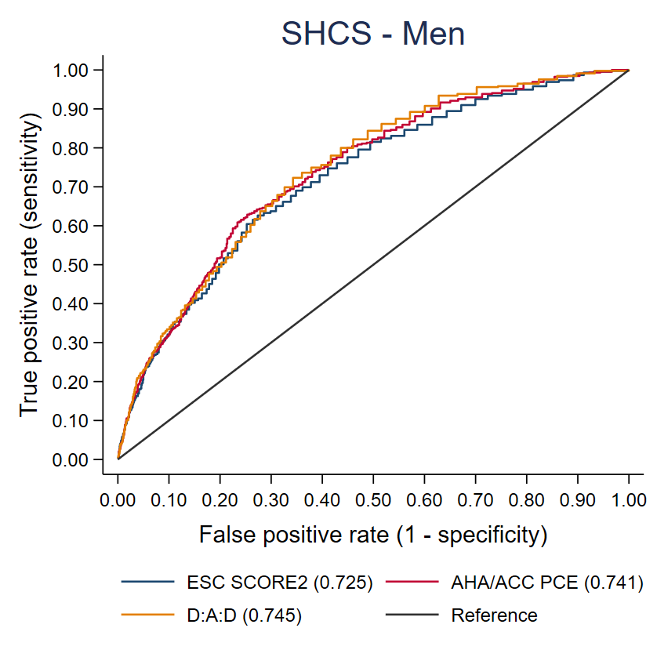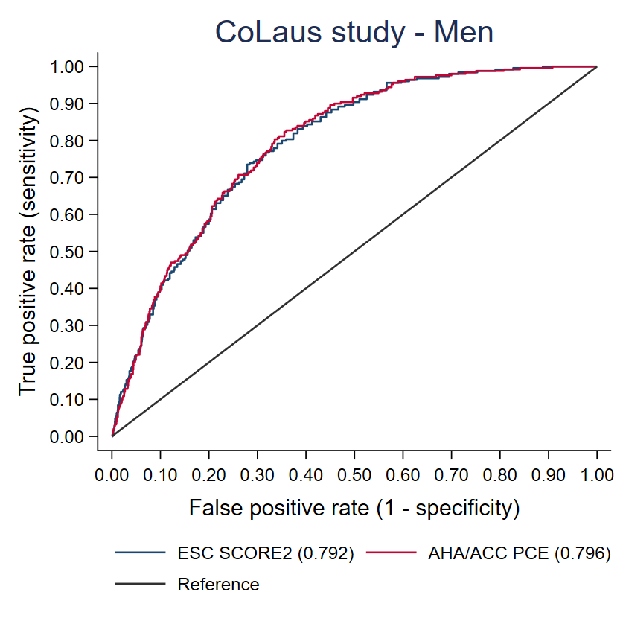

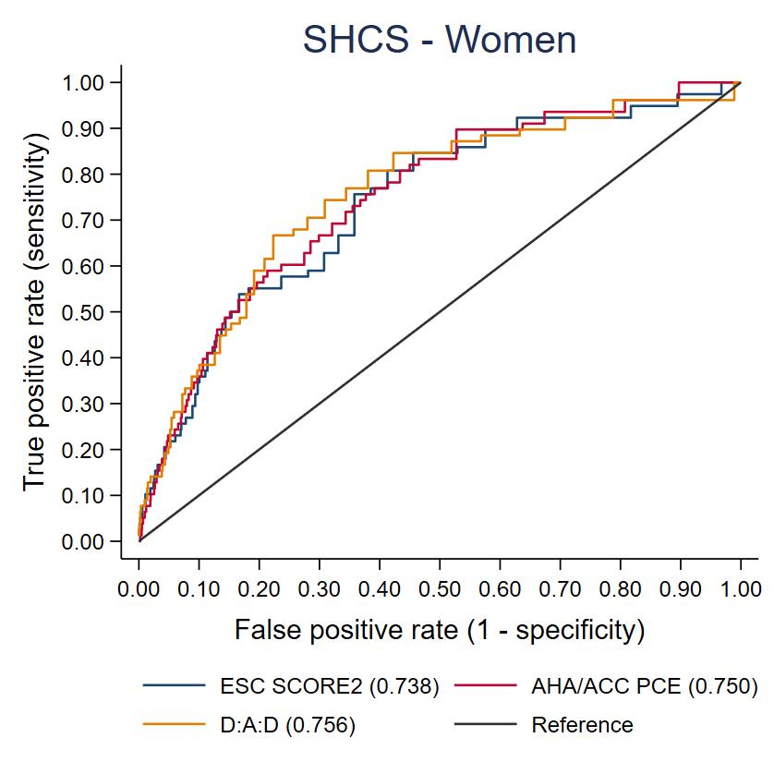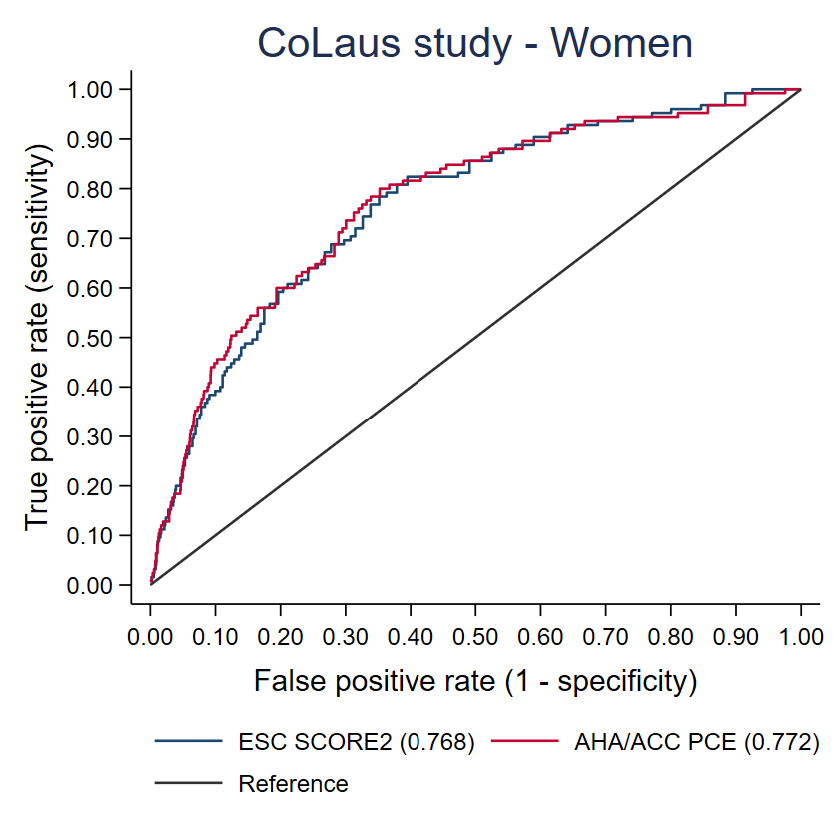

Area under the receiver operating characteristic curves statistics are presented in parenthesis. All scores were dichotomized into low/intermediate versus high/very high categories of risk. SHCS: Men, N=4566 ASCVD events=455; Women, N=1807 ASCVD events=78. CoLaus|PsyCoLaus study: Men, N=2511 ASCVD events=249; Women, N=2892 ASCVD events=125.

Abbreviations: ACC, American College of Cardiology; AHA, American Heart Association; D:A:D, Data collection on Adverse Effects of Anti-HIV Drugs; ESC, European Society of Cardiology; PCE, Pooled Cohort Equations; SCORE2, Systematic Coronary Risk Evaluation 2.

**Supplementary figure 3.** Accuracy of the different scores in predicting ASCVD according to ethnicity in each cohort (D:A:D score only in SHCS).

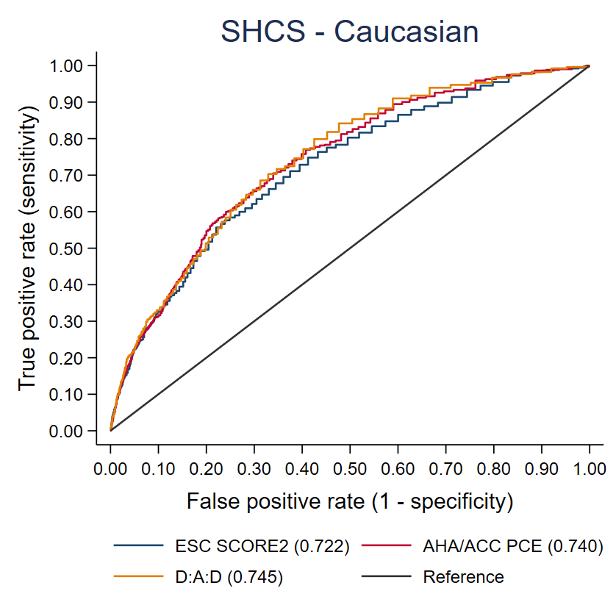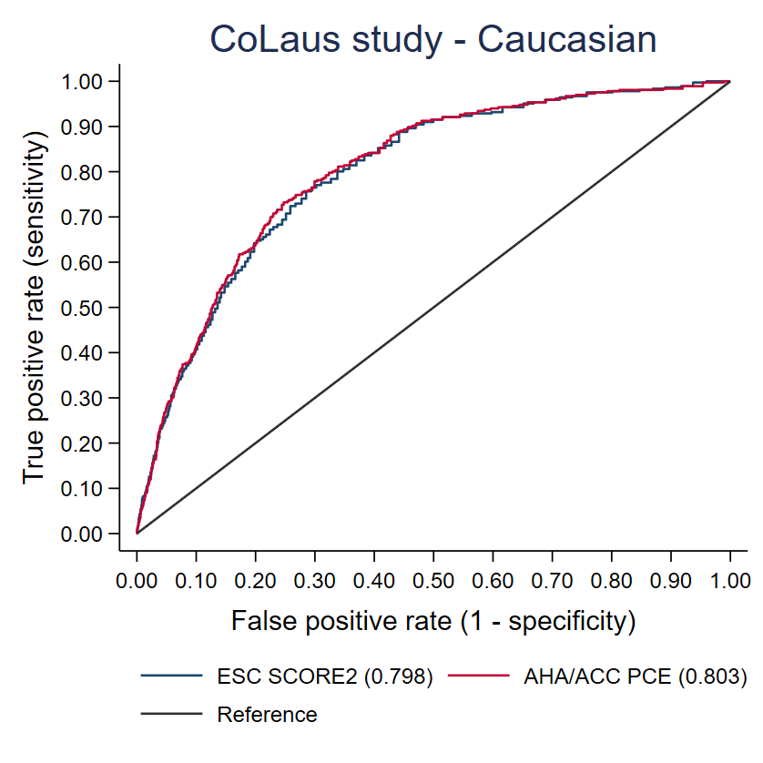

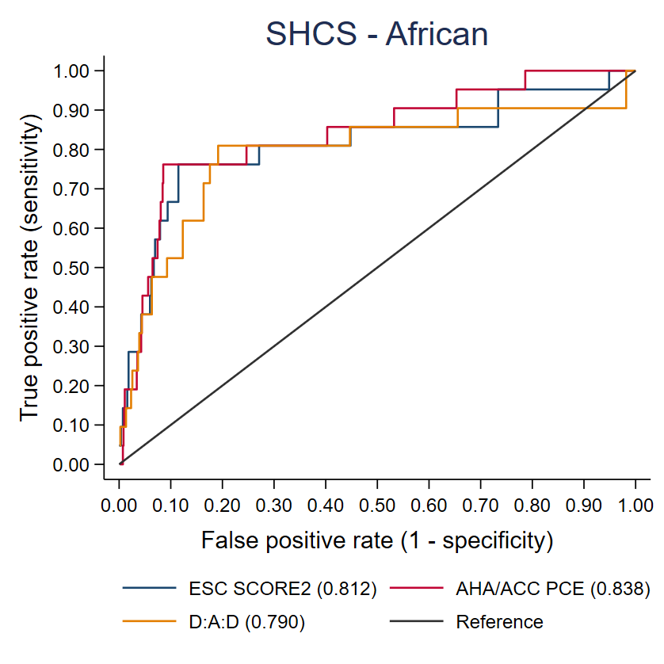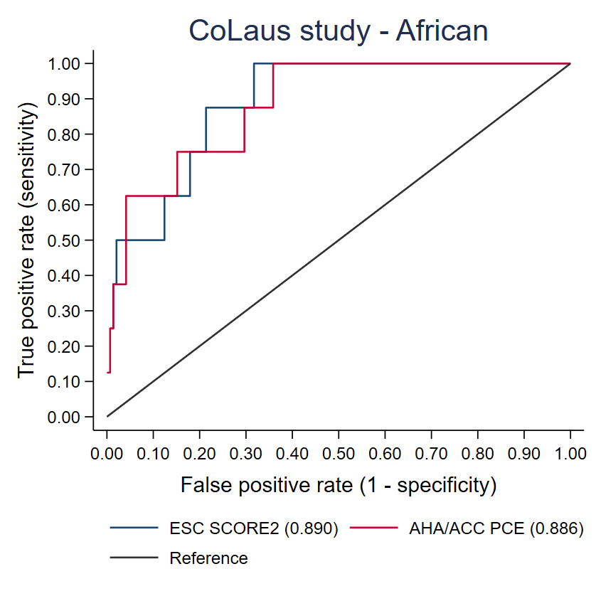

Area under the receiver operating characteristic curves statistics are presented in parenthesis. All scores were dichotomized into low/intermediate versus high/very high categories of risk. SHCS: Caucasian, N=5533 ASCVD events=512; African, N=840 ASCVD events=21. CoLaus|PsyCoLaus study: Caucasian, N=5250 ASCVD events=366; African, N=153 ASCVD events=8.

Abbreviations: ACC, American College of Cardiology; AHA, American Heart Association; D:A:D, Data collection on Adverse Effects of Anti-HIV Drugs; ESC, European Society of Cardiology; PCE, Pooled Cohort Equations; SCORE2, Systematic Coronary Risk Evaluation 2.

**Supplementary figure 4.** Accuracy of the different scores in predicting ASCVD, according to date of enrollment in SHCS.

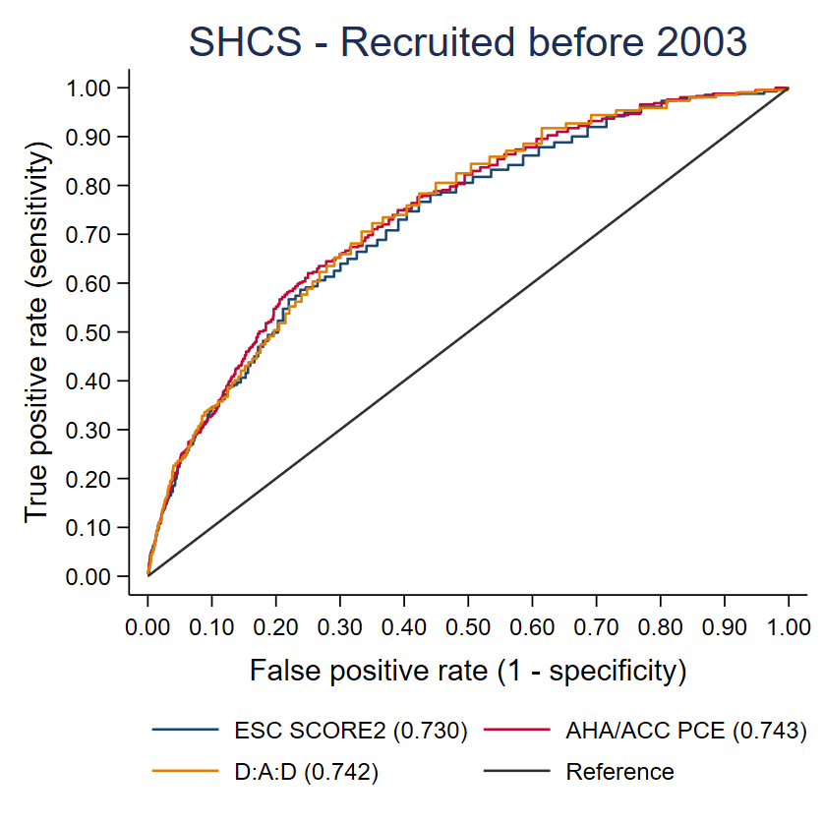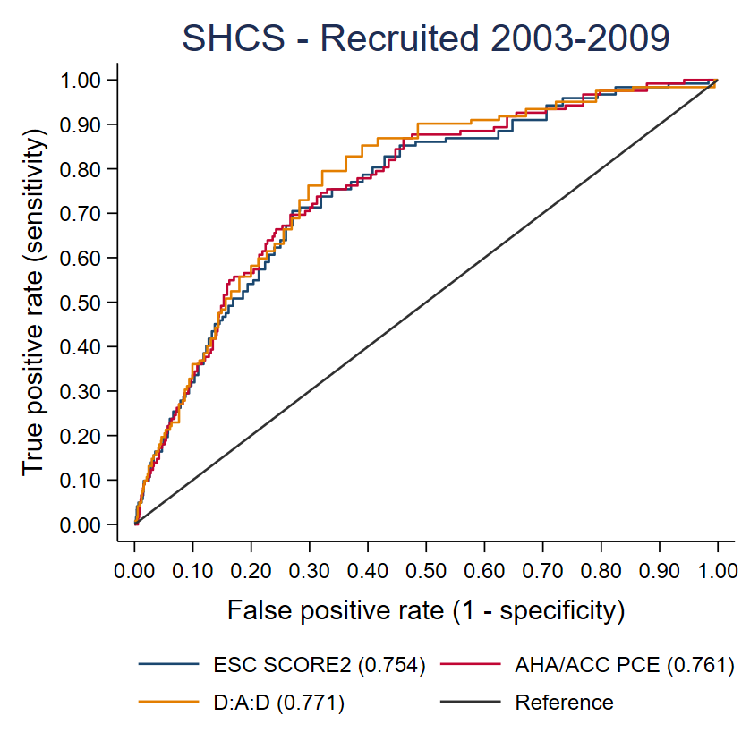

Area under the receiver operating characteristic curves statistics are presented in parenthesis. All scores were dichotomized into low/intermediate versus high/very high categories of risk. Participants enrolled before 2003, N=5533 ASCVD events=411; Participants enrolled from 2003 to 2009, N=2521 ASCVD events=122.

Abbreviations: ACC, American College of Cardiology; AHA, American Heart Association; D:A:D, Data collection on Adverse Effects of Anti-HIV Drugs; ESC, European Society of Cardiology; PCE, Pooled Cohort Equations; SCORE2, Systematic Coronary Risk Evaluation 2.

**Supplementary figure 5.** Predicted and observed ASCVD, according to sex.

***Panel A***. SHCS.

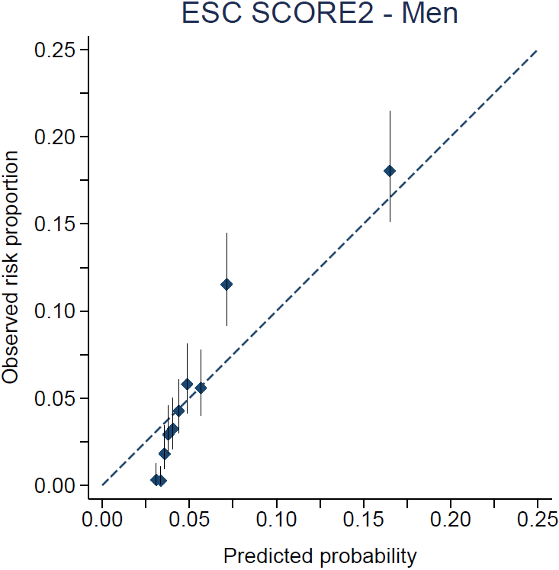 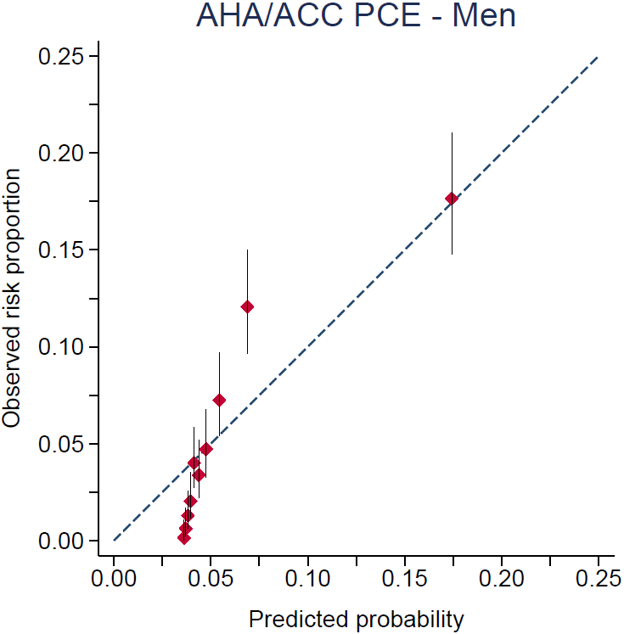 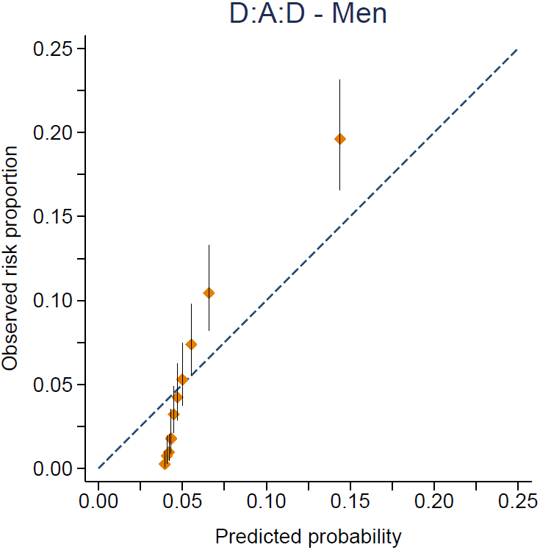

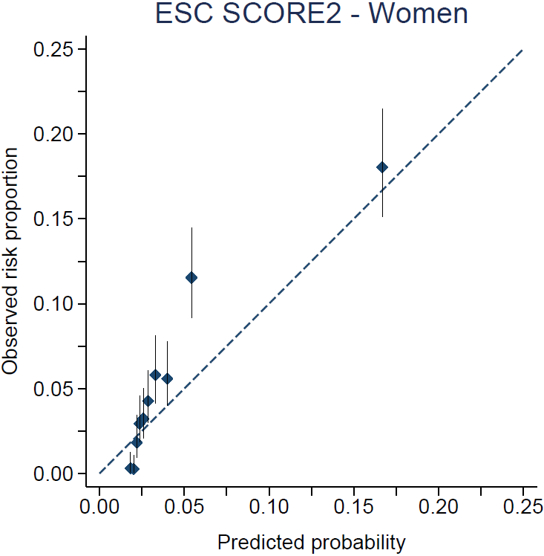 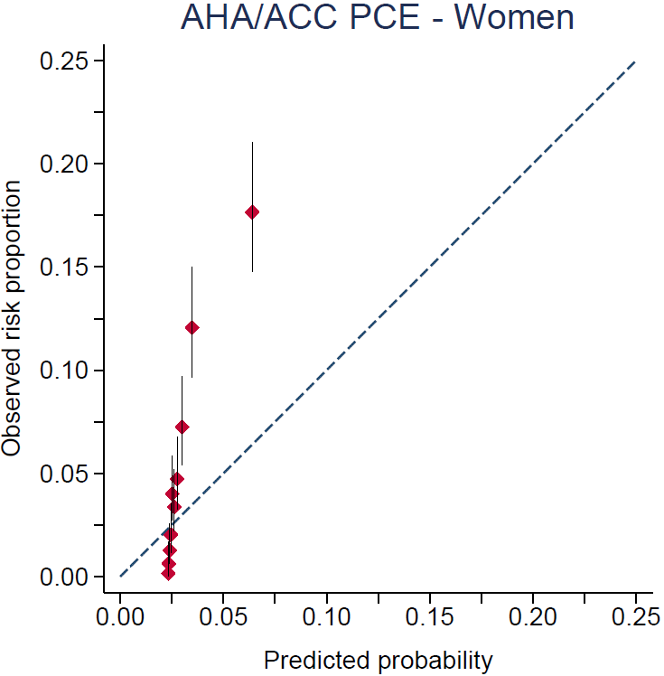 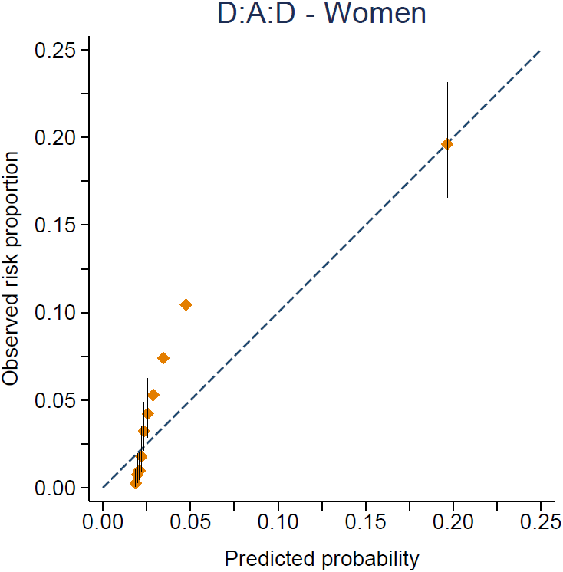

***Panel B.*** CoLaus|PsyCoLaus study.

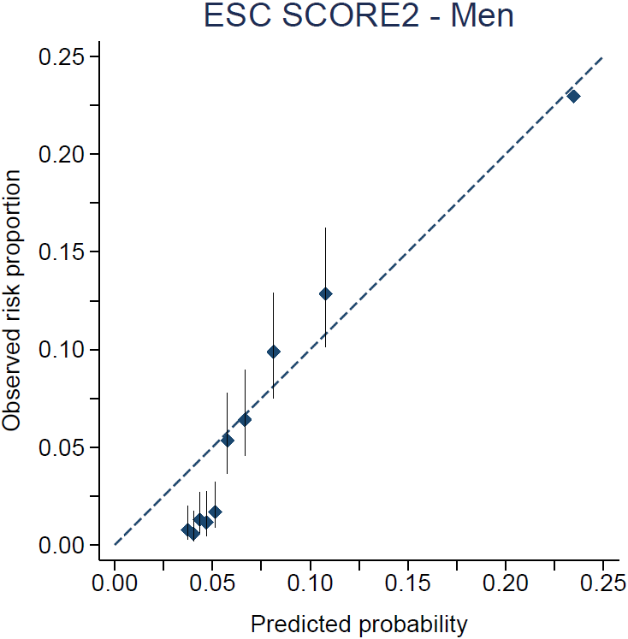 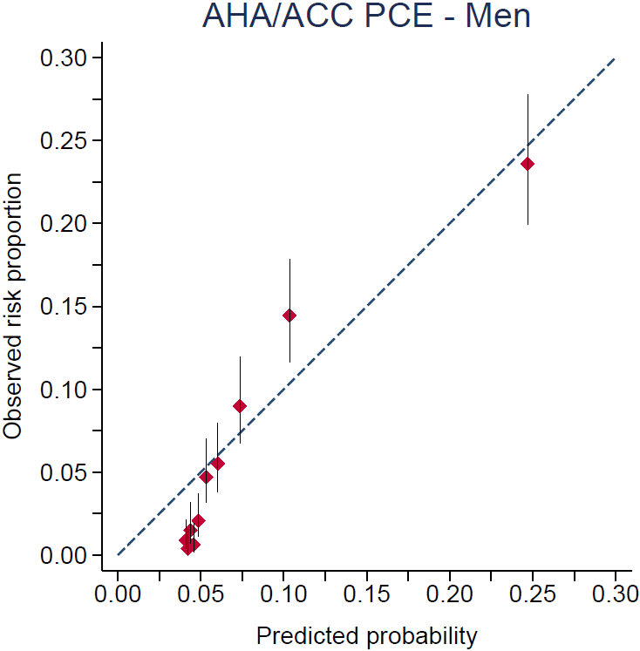

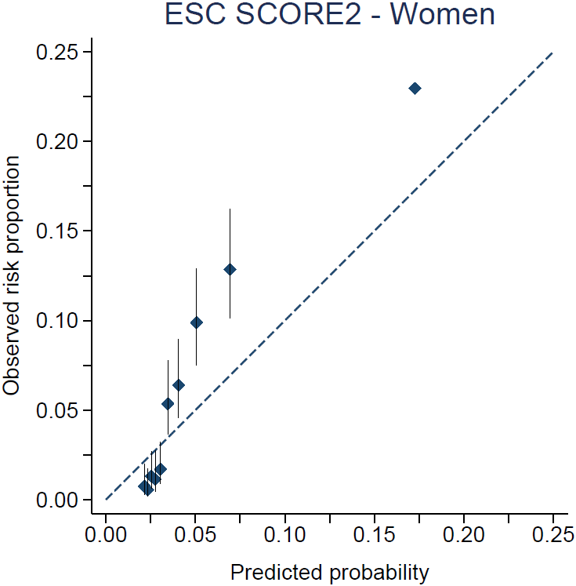 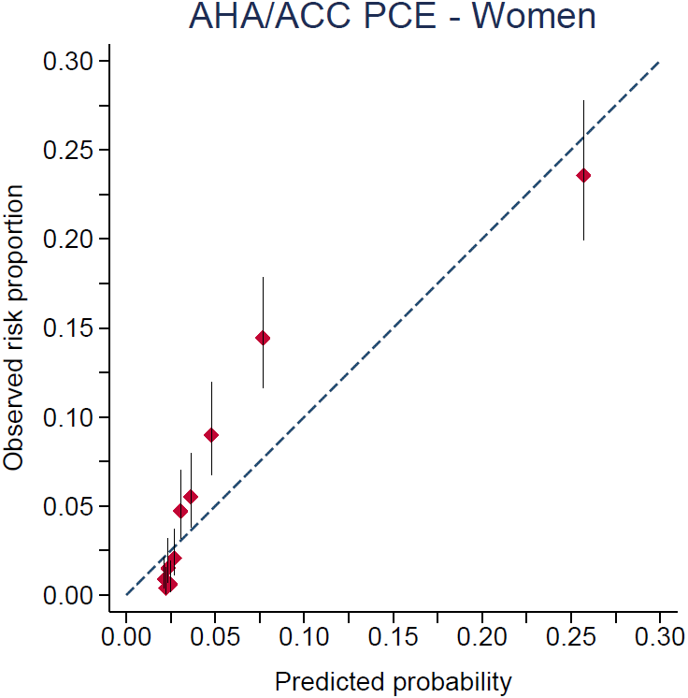

Calibration plots of cardiovascular risk score (SHCS: Men, N=4566; Women, N=1807. CoLaus|PsyCoLaus study: Men, N=2511; Women, N=2892). Observed risk scores outcome (i.e., common set of ASCVD) in the risk prediction model analysis were calculated using Kaplan-Meier estimates. Participants are divided into 10 deciles of risk represented by diamonds. Vertical bars indicate 95% confidence intervals.

Abbreviations: ACC, American College of Cardiology; AHA, American Heart Association; D:A:D, Data collection on Adverse Effects of Anti-HIV Drugs; ESC, European Society of Cardiology; PCE, Pooled Cohort Equations; SCORE2, Systematic Coronary Risk Evaluation 2.

**Supplementary figure 6.** Predicted and observed ASCVD, according to ethnicity.

***Panel A***. SHCS

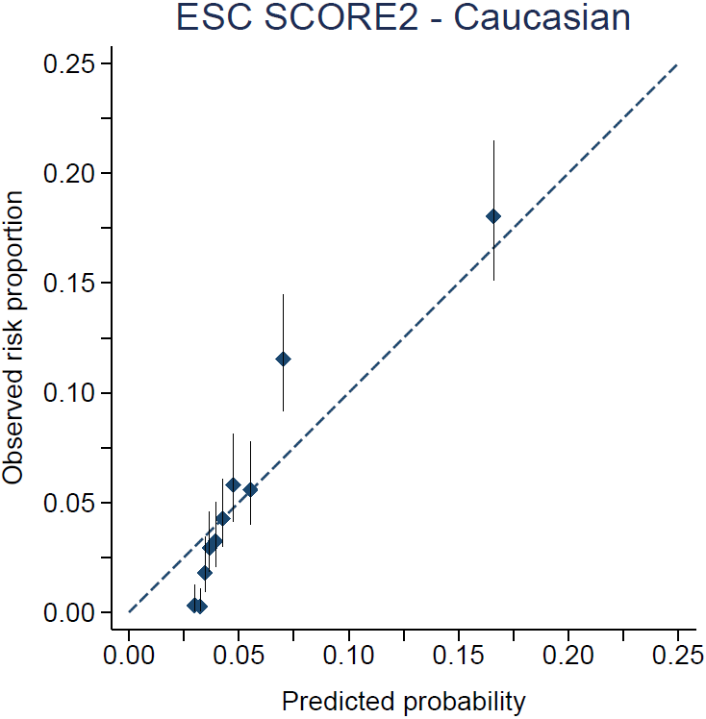 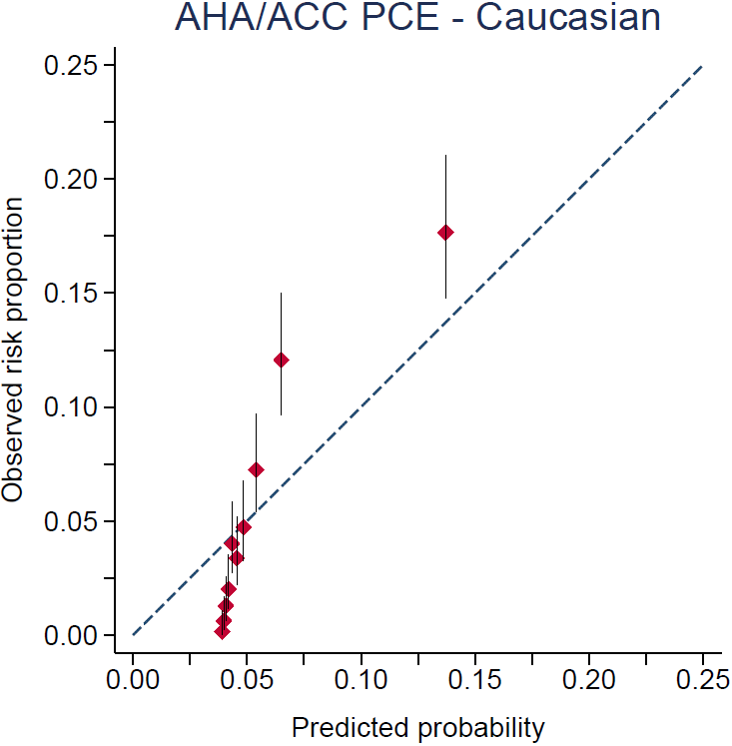 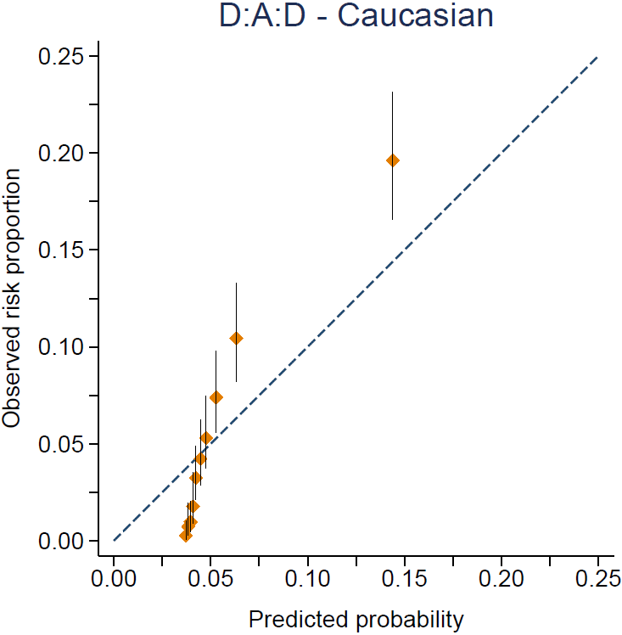

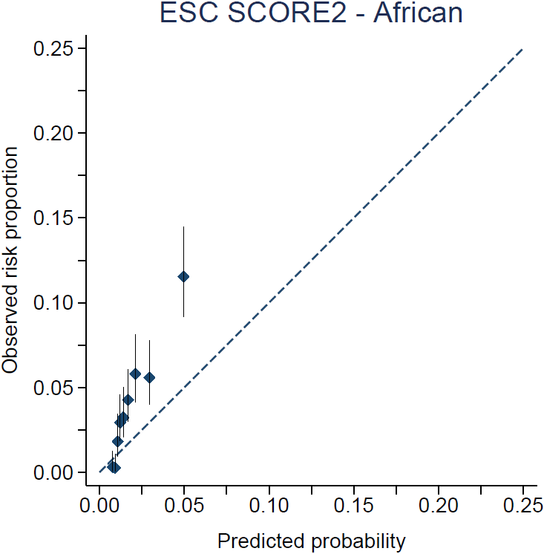 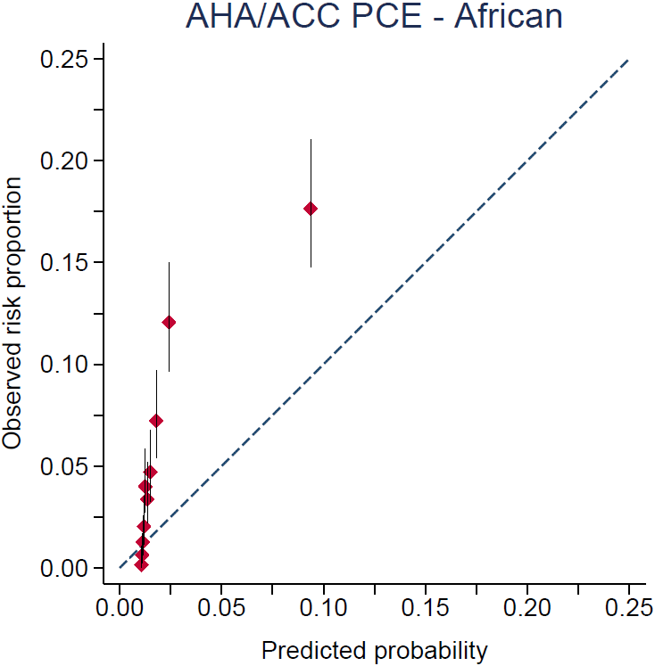 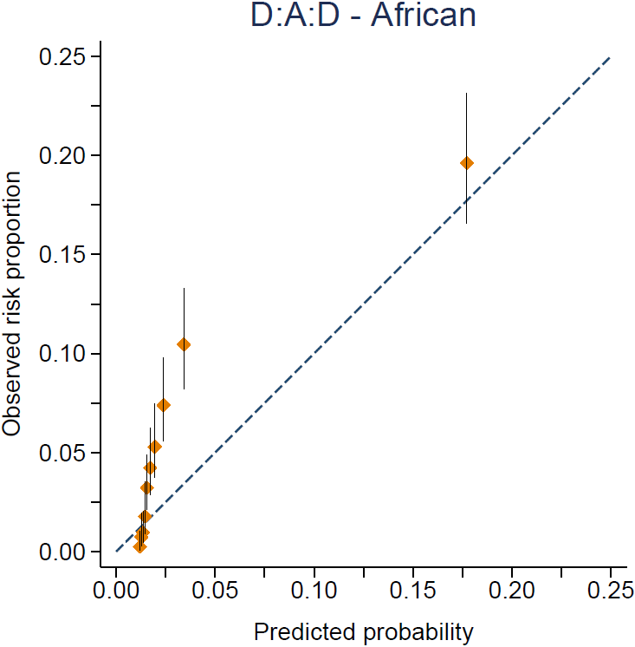

***Panel B.*** CoLaus|PsyCoLaus study

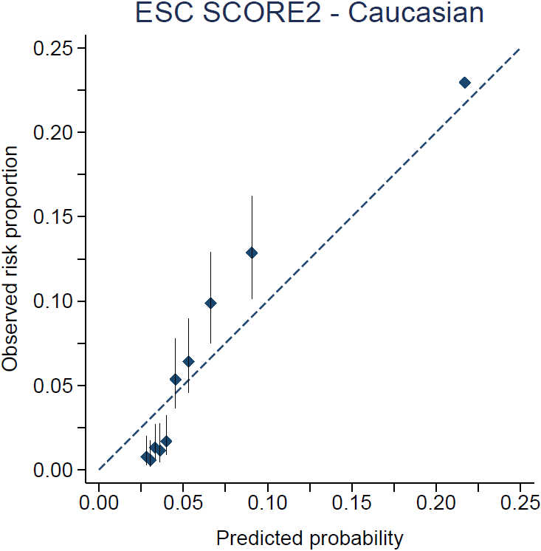 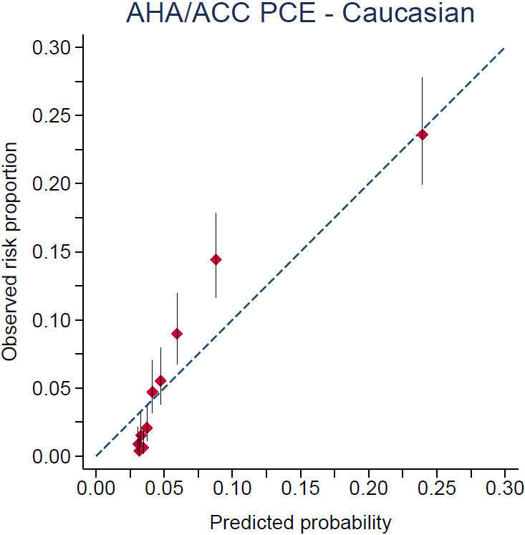

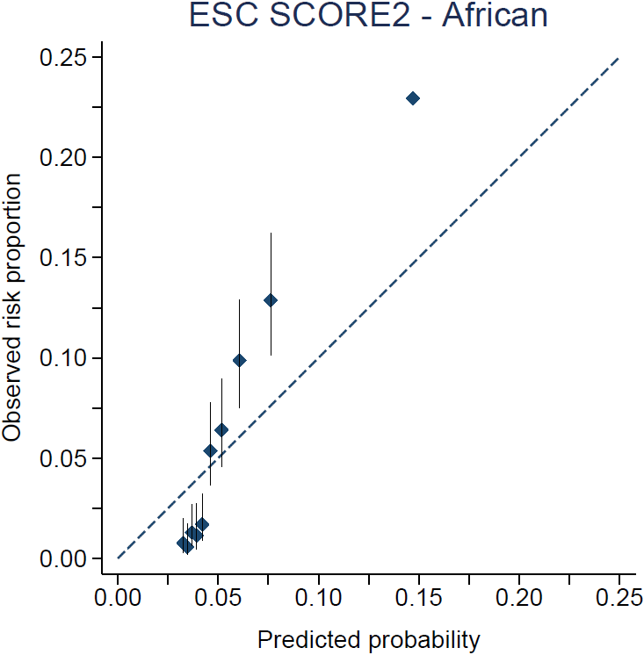 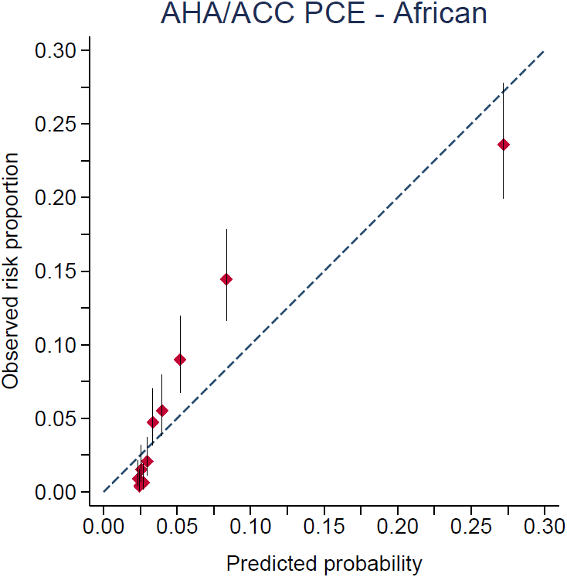

Calibration plots of cardiovascular risk score (SHCS: Caucasian, N=5533; African, N=840. CoLaus|PsyCoLaus study: Caucasian, N=5250; African, N=153). Observed risk scores outcome (i.e., common set of ASCVD) in the risk prediction model analysis were calculated using Kaplan-Meier estimates. Participants are divided into 10 deciles of risk represented by diamonds. Vertical bars indicate 95% confidence intervals.

Abbreviations: ACC, American College of Cardiology; AHA, American Heart Association; D:A:D, Data collection on Adverse Effects of Anti-HIV Drugs; ESC, European Society of Cardiology; PCE, Pooled Cohort Equations; SCORE2, Systematic Coronary Risk Evaluation 2.

**Supplementary figure 7.** Predicted and observed ASCVD, according to date of enrollment in SHCS.

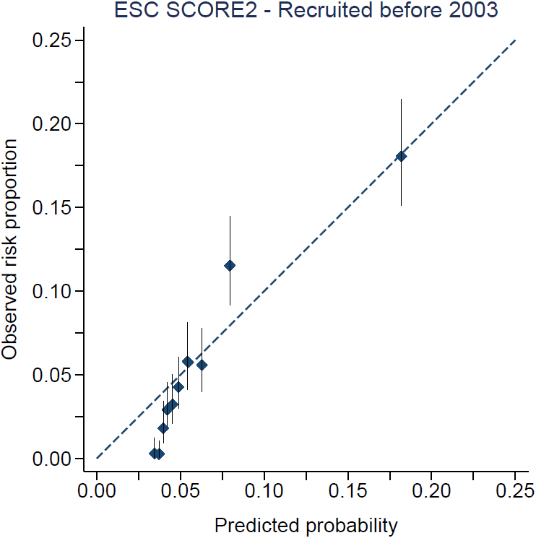 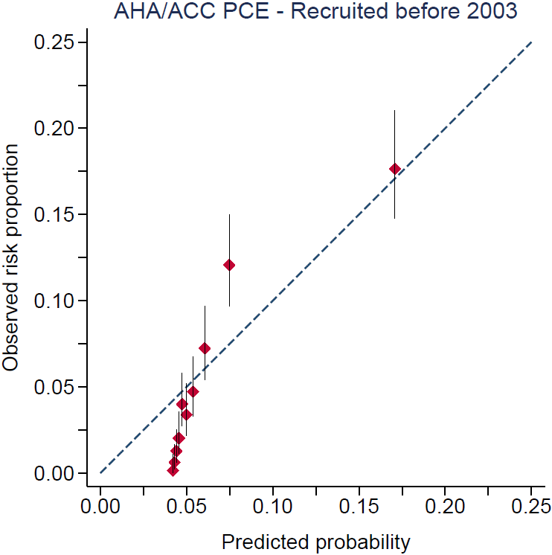 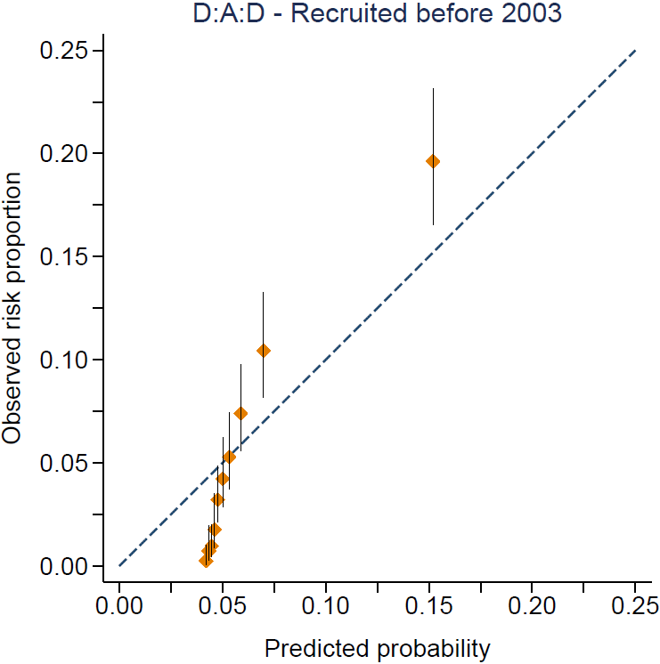

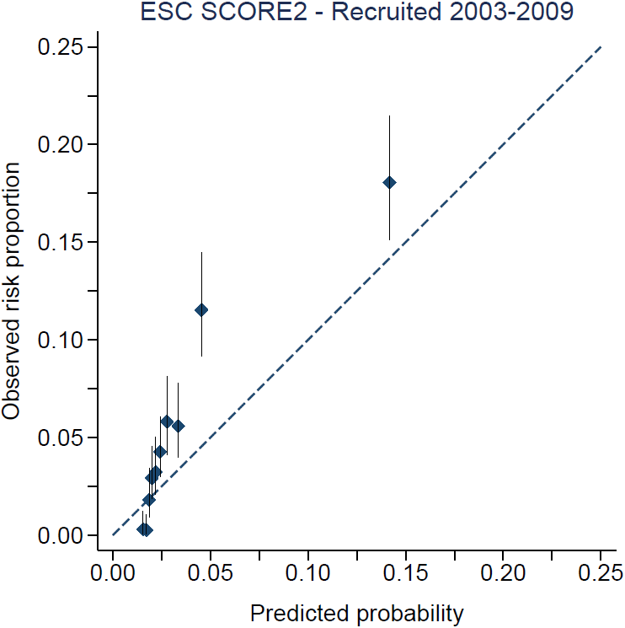 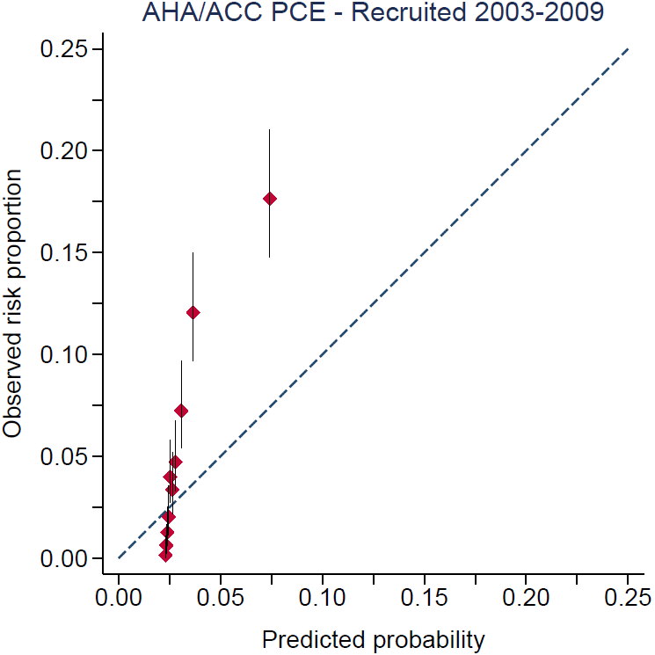 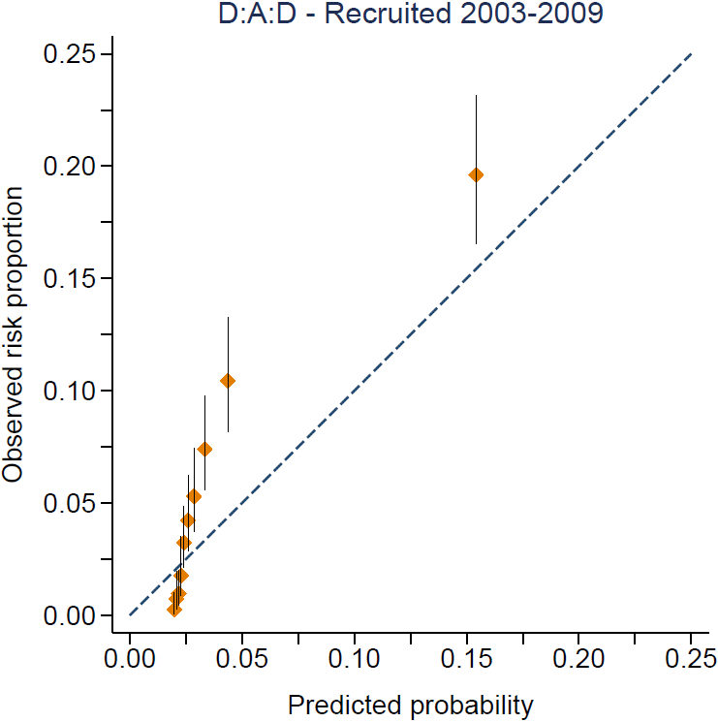

Calibration plots of cardiovascular risk score (Participants enrolled before 2003, N=5533; Participants enrolled from 2003 to 2009). Observed risk scores outcome (i.e., common set of ASCVD) in the risk prediction model analysis were calculated using Kaplan-Meier estimates. Participants are divided into 10 deciles of risk represented by diamonds. Vertical bars indicate 95% confidence intervals.

Abbreviations: ACC, American College of Cardiology; AHA, American Heart Association; D:A:D, Data collection on Adverse Effects of Anti-HIV Drugs; ESC, European Society of Cardiology; PCE, Pooled Cohort Equations; SCORE2, Systematic Coronary Risk Evaluation 2.

**Supplementary figure 8.** Net reclassification improvement of ESC SCORE2 and AHA/ACC PCE using HIV-specific variables.

|  |  |  |  |  |  |  |  |  |  |
| --- | --- | --- | --- | --- | --- | --- | --- | --- | --- |
|  | **Controls** | **SCORE2 risk with HIV variables** | | |  |  |  |  |  |
|  | **risk categories** |  | | |  |  |  |  |  |
|  |  | **Low-to-moderate** | **High** | **Very high** | **Total** |  |  |  |  |
| **SCORE2 risk** | **Low-to-moderate** | 3900 | 24 | 0 | **3924** | **Controls** | **- 0.3%** |  |  |
| **High** | 1 | 1692 | 0 | **1693** |  |  |  |  |
| **Very high** | 0 | 5 | 218 | **223** |  |  |  |  |
|  | **Total** | **3901** | **1721** | **218** | **5840** |  |  |  |  |
|  |  |  |  |  |  |  |  |  |  |
|  | **Cases** | **SCORE2 risk with HIV variables** | | |  |  |  |  |  |
|  | **risk categories** |  |  |  |  |  |
|  |  | **Low-to-moderate** | **High** | **Very high** | **Total** |  |  |  |  |
| **SCORE2 risk** | **Low-to-moderate** | 154 | 5 | 0 | **159** | **Cases** | **0.2%** |  |  |
| **High** | 1 | 264 | 0 | **265** |  |  |  |  |
| **Very high** | 0 | 3 | 106 | **109** |  |  |  |  |
|  | **Total** | **155** | **272** | **106** | **533** | **Total** | **- 0.1%** | **(95%CI: -1.24, 1)** | **P-value= 0.83** |
|  |  |  |  |  |  |  |  |  |  |
|  |  |  |  |  |  |  |  |  |  |
|  |  |  |  |  |  |  |  |  |  |
|  |  |  |  |  |  |  |  |  |  |
|  |  |  |  |  |  |  |  |  |  |
|  |  |  |  |  |  |  |  |  |  |
|  |  |  |  |  |  |  |  |  |  |
|  |  |  |  |  |  |  |  |  |  |
|  |  |  |  |  |  |  |  |  |  |
|  |  |  |  |  |  |  |  |  |  |
|  |  |  |  |  |  |  |  |  |  |
|  |  |  |  |  |  |  |  |  |  |
|  |  |  |  |  |  |  |  |  |  |
|  | **Controls** | **PCE risk with HIV variables** | | |  |  |  |  |  |
|  | **risk categories** |  |  |  |  |  |
|  |  | **Low (<5%)** | **Borderline (5-7.5%)** | **High (>7.5%)** | **Total** |  |  |  |  |
| **PCE risk** | **Low (<5%)** | 4226 | 99 | 0 | **4325** | **Controls** | **0.3%** |  |  |
| **Borderline (5-7.5%)** | 90 | 169 | 47 | **306** |  |  |  |  |
| **High (>7.5%)** | 0 | 71 | 1138 | **1209** |  |  |  |  |
|  | **Total** | **4316** | **339** | **1185** | **5840** |  |  |  |  |
|  |  |  |  |  |  |  |  |  |  |
|  | **Cases** | **PCE risk with HIV variables** | | |  |  |  |  |  |
|  | **risk categories** |  |  |  |  |  |
|  |  | **Low (<5%)** | **Borderline (5-7.5%)** | **High (>7.5%)** | **Total** |  |  |  |  |
| **PCE risk** | **Low (<5%)** | 128 | 10 | 0 | **139** | **Cases** | **2.4%** |  |  |
| **Borderline (5-7.5%)** | 6 | 12 | 17 | **32** |  |  |  |  |
| **High (>7.5%)** | 0 | 8 | 352 | **362** |  |  |  |  |
|  | **Total** | **134** | **30** | **369** | **533** | **Total** | **2.7%** | **(95%CI: 0.3, 5.1)** | **P-value= 0.03** |

CD4 T cells nadir <200 cells/mm3 (yes/no) and exposure to abacavir (yes/no) were added to the PCE score Cox prediction model.

Abbreviations: AHA, American Heart Association; ESC, European Society of Cardiology; NRI, net reclassification improvement; PCE, Pooled Cohort Equations; SCORE2, Systematic Coronary Risk Evaluation 2.

**References**

1. Goff DC, Jr., Lloyd-Jones DM, Bennett G, Coady S, D'Agostino RB, Sr., Gibbons R, Greenland P, Lackland DT, Levy D, O'Donnell CJ, Robinson JG, Schwartz JS, Shero ST, Smith SC, Jr., Sorlie P, Stone NJ, Wilson PWF. 2013 ACC/AHA guideline on the assessment of cardiovascular risk: a report of the American College of Cardiology/American Heart Association Task Force on Practice Guidelines. J Am Coll Cardiol 2014;**63**(25 Pt B):2935-2959.

2. de Las Heras Gala T, Geisel MH, Peters A, Thorand B, Baumert J, Lehmann N, Jöckel KH, Moebus S, Erbel R, Meisinger C, Mahabadi AA, Koenig W. Recalibration of the ACC/AHA Risk Score in Two Population-Based German Cohorts. PLoS One 2016;**11**(10):e0164688.

3. Catapano AL, Graham I, De Backer G, Wiklund O, Chapman MJ, Drexel H, Hoes AW, Jennings CS, Landmesser U, Pedersen TR, Reiner Ž, Riccardi G, Taskinen MR, Tokgozoglu L, Verschuren WMM, Vlachopoulos C, Wood DA, Zamorano JL, Cooney MT. 2016 ESC/EAS Guidelines for the Management of Dyslipidaemias. Eur Heart J 2016;**37**(39):2999-3058.