A GIS-Based Approach to Assess the Influence of the Urban Built Environment on Cardiac and Respiratory Outcomes in Older Adults

Hélène Niculita-Hirzel, Alexandre H. Hirzel, Pascal Wild

Figure S1. Geospatial localization of dwellings considered in the study.

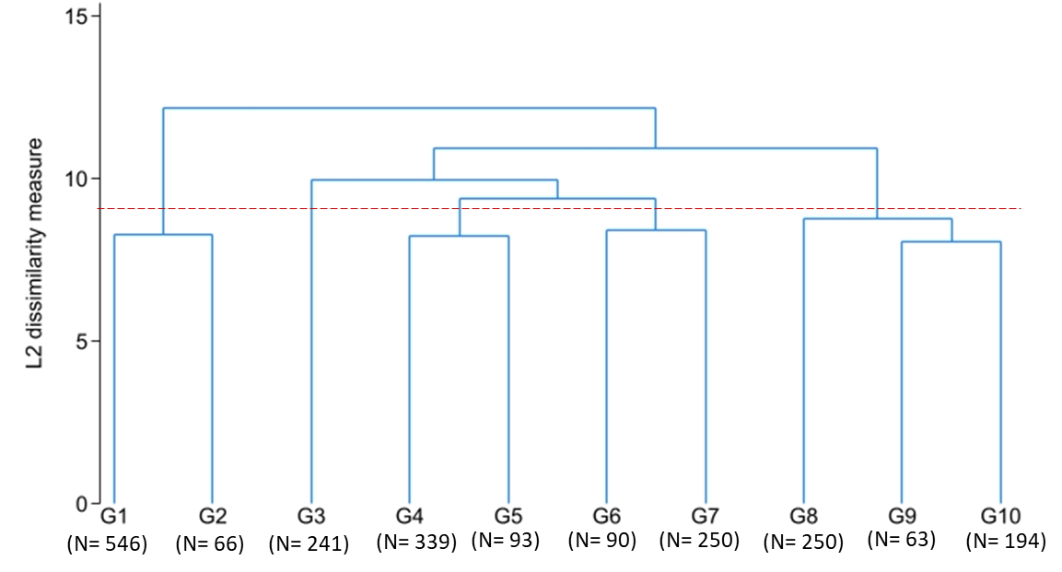
Figure S2. Dendrogram of agglomerative hierarchical cluster analysis

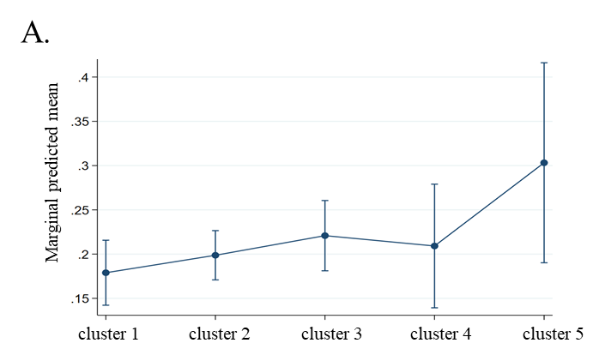
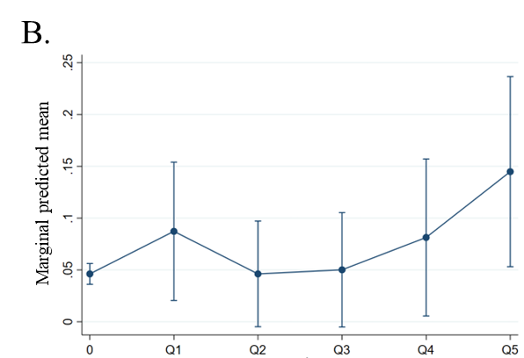
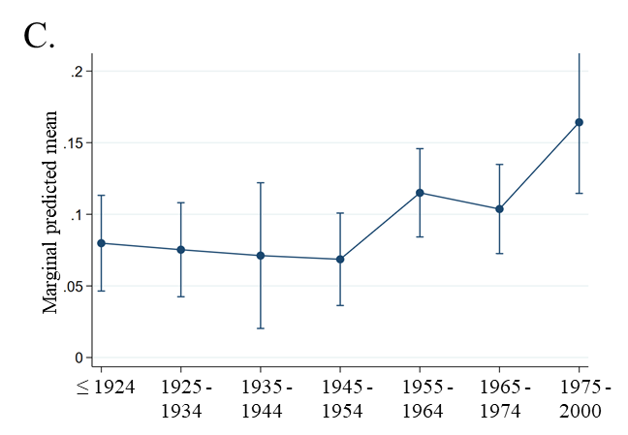

Figure S3. Marginal predicted mean of health outcomes by built environment descriptor, with 95% confidence intervals. A. Proportion of heart medication by urban landscape cluster; B. Proportion of medication for asthma by quantile of proximity to the lake; C. Proportion of chronic lung disease by construction period of the building.

Table S1. Number of participants residing in buildings from each construction period
Building constuction period | Participants
before 1925 | 258
1925-1934 | 256
1935-1944 | 102
1945-1954 | 257
1955-1964 | 447
1965-1974 | 423
1975-2014 | 258

Table S2. Descriptive statistics of road density variable in the five urban landscape clusters.
Cluster | Q1 | Q2 | Q3 | Q4 | Q5 | Total
1 (N) | 213 | 155 | 74 | 31 | 0 | 473
1 (%) | 45.03 | 32.77 | 15.64 | 6.55 | 0 | 100
2 (N) | 183 | 219 | 277 | 203 | 34 | 916
2 (%) | 19.98 | 23.91 | 30.24 | 22.16 | 3.71 | 100
3 (N) | 0 | 35 | 61 | 106 | 307 | 509
3 (%) | 0 | 6.88 | 11.98 | 20.83 | 60.31 | 100
4 (N) | 0 | 0 | 3 | 37 | 98 | 138
4 (%) | 0 | 0 | 2.17 | 26.81 | 71.01 | 100
5 (N) | 28 | 11 | 8 | 28 | 6 | 81
5 (%) | 34.57 | 13.58 | 9.88 | 34.57 | 7.41 | 100
Total (N) | 424 | 420 | 423 | 405 | 445 | 2117
Total (%) | 20.03 | 19.84 | 19.98 | 19.13 | 21.02 | 100

Table S3. Descriptive statistics of building density variable in the five urban landscape clusters
Cluster | Q1 | Q2 | Q3 | Q4 | Q5 | Total
1 (N) | 295 | 165 | 13 | 0 | 0 | 473
1 (%) | 62.37 | 34.88 | 2.75 | 0 | 0 | 100
2 (N) | 97 | 251 | 319 | 211 | 38 | 916
2 (%) | 10.59 | 27.4 | 34.83 | 23.03 | 4.15 | 100
3 (N) | 0 | 0 | 30 | 136 | 343 | 509
3 (%) | 0 | 0 | 5.89 | 26.72 | 67.39 | 100
4 (N) | 1 | 5 | 36 | 85 | 11 | 138
4 (%) | 0.72 | 3.62 | 26.09 | 61.59 | 7.97 | 100
5 (N) | 33 | 18 | 29 | 1 | 0 | 81
5 (%) | 40.74 | 22.22 | 35.8 | 1.23 | 0 | 100
Total (N) | 426 | 439 | 427 | 433 | 392 | 2117
Total (%) | 20.12 | 20.74 | 20.17 | 20.45 | 18.52 | 100

Table S4. Descriptive statistics of elevation variable in the five urban landscape clusters
Cluster | Q1 | Q2 | Q3 | Q4 | Q5 | Total
1 (N) | 27 | 55 | 43 | 48 | 300 | 473
1 (%) | 5.71 | 11.63 | 9.09 | 10.15 | 63.42 | 100
2 (N) | 112 | 84 | 224 | 397 | 99 | 916
2 (%) | 12.23 | 9.17 | 24.45 | 43.34 | 10.81 | 100
3 (N) | 130 | 226 | 151 | 2 | 0 | 509
3 (%) | 25.54 | 44.4 | 29.67 | 0.39 | 0 | 100
4 (N) | 77 | 61 | 0 | 0 | 0 | 138
4 (%) | 55.8 | 44.2 | 0 | 0 | 0 | 100
5 (N) | 81 | 0 | 0 | 0 | 0 | 81
5 (%) | 100 | 0 | 0 | 0 | 0 | 100
Total (N) | 427 | 426 | 418 | 447 | 399 | 2117
Total (%) | 20.17 | 20.12 | 19.74 | 21.11 | 18.85 | 100

Table S5. Descriptive statistics of proximity to Geneva Lake variable in the five urban landscape clusters.
Cluster | NA | Q1 | Q2 | Q3 | Q4 | Q5 | Total
1 (N) | 440 | 3 | 0 | 30 | 0 | 0 | 473
1 (%) | 93.02 | 0.63 | 0 | 6.34 | 0 | 0 | 100
2 (N) | 912 | 2 | 1 | 1 | 0 | 0 | 916
2 (%) | 99.56 | 0.22 | 0.11 | 0.11 | 0 | 0 | 100
3 (N) | 443 | 63 | 3 | 0 | 0 | 0 | 509
3 (%) | 87.03 | 12.38 | 0.59 | 0 | 0 | 0 | 100
4 (N) | 0 | 1 | 60 | 29 | 24 | 24 | 138
4 (%) | 0 | 0.72 | 43.48 | 21.01 | 17.39 | 17.39 | 100
5 (N) | 0 | 0 | 0 | 2 | 38 | 41 | 81
5 (%) | 0 | 0 | 0 | 2.47 | 46.91 | 50.62 | 100
Total (N) | 1,795 | 69 | 64 | 62 | 62 | 65 | 2117
Total (%) | 84.79 | 3.26 | 3.02 | 2.93 | 2.93 | 3.07 | 100

Table S6. Descriptive statistics of proximity to water other than lake variable in the five urban landscape clusters.
Cluster | NA | Q1 | Q2 | Q3 | Q4 | Q5 | Total
1 (N) | 0 | 0 | 49 | 82 | 129 | 213 | 473
1 (%) | 0 | 0 | 10.36 | 17.34 | 27.27 | 45.03 | 100
2 (N) | 531 | 109 | 103 | 101 | 72 | 0 | 916
2 (%) | 57.97 | 11.9 | 11.24 | 11.03 | 7.86 | 0 | 100
3 (N) | 348 | 84 | 40 | 31 | 6 | 0 | 509
3 (%) | 68.37 | 16.5 | 7.86 | 6.09 | 1.18 | 0 | 100
4 (N) | 137 | 1 | 0 | 0 | 0 | 0 | 138
4 (%) | 99.28 | 0.72 | 0 | 0 | 0 | 0 | 100
5 (N) | 27 | 1 | 21 | 10 | 13 | 9 | 81
5 (%) | 33.33 | 1.23 | 25.93 | 12.35 | 16.05 | 11.11 | 100
Total (N) | 1,043 | 195 | 213 | 224 | 220 | 222 | 2117
Total (%) | 49.27 | 9.21 | 10.06 | 10.58 | 10.39 | 10.49 | 100

Table S7. Descriptive statistics of proximity to forest variable in the five urban landscape clusters.
Cluster | NA | Q1 | Q2 | Q3 | Q4 | Q5 | Total
1 (N) | 0 | 0 | 0 | 47 | 168 | 258 | 473
1 (%) | 0 | 0 | 0 | 9.94 | 35.52 | 54.55 | 100
2 (N) | 14 | 51 | 188 | 274 | 246 | 143 | 916
2 (%) | 1.53 | 5.57 | 20.52 | 29.91 | 26.86 | 15.61 | 100
3 (N) | 47 | 239 | 153 | 65 | 5 | 0 | 509
3 (%) | 9.23 | 46.95 | 30.06 | 12.77 | 0.98 | 0 | 100
4 (N) | 30 | 76 | 32 | 0 | 0 | 0 | 138
4 (%) | 21.74 | 55.07 | 23.19 | 0 | 0 | 0 | 100
5 (N) | 14 | 19 | 32 | 8 | 8 | 0 | 81
5 (%) | 17.28 | 23.46 | 39.51 | 9.88 | 9.88 | 0 | 100
Total (N) | 105 | 385 | 405 | 394 | 427 | 401 | 2117
Total (%) | 4.96 | 18.19 | 19.13 | 18.61 | 20.17 | 18.94 | 100

Table S8. Descriptive statistics of proximity to garden variable in the five urban landscape clusters.
Cluster | NA | Q2 | Q3 | Q4 | Q5 | Total
1 (N) | 41 | 106 | 104 | 93 | 129 | 473
1 (%) | 8.67 | 22.41 | 21.99 | 19.66 | 27.27 | 100
2 (N) | 1 | 66 | 261 | 297 | 291 | 916
2 (%) | 0.11 | 7.21 | 28.49 | 32.42 | 31.77 | 100
3 (N) | 319 | 170 | 19 | 1 | 0 | 509
3 (%) | 62.67 | 33.4 | 3.73 | 0.2 | 0 | 100
4 (N) | 37 | 61 | 25 | 15 | 0 | 138
4 (%) | 26.81 | 44.2 | 18.12 | 10.87 | 0 | 100
5 (N) | 5 | 18 | 24 | 15 | 19 | 81
5 (%) | 6.17 | 22.22 | 29.63 | 18.52 | 23.46 | 100
Total (N) | 403 | 421 | 433 | 421 | 439 | 2117
Total (%) | 19.04 | 19.89 | 20.45 | 19.89 | 20.74 | 100

Table S9. Descriptive statistics of proximity to field variable in the five urban landscape clusters.
Cluster | NA | Q1 | Q2 | Q3 | Q4 | Q5 | Total
1 (N) | 42 | 6 | 65 | 109 | 104 | 147 | 473
1 (%) | 8.88 | 1.27 | 13.74 | 23.04 | 21.99 | 31.08 | 100
2 (N) | 540 | 93 | 51 | 49 | 110 | 73 | 916
2 (%) | 58.95 | 10.15 | 5.57 | 5.35 | 12.01 | 7.97 | 100
3 (N) | 269 | 72 | 76 | 82 | 10 | 0 | 509
3 (%) | 52.85 | 14.15 | 14.93 | 16.11 | 1.96 | 0 | 100
4 (N) | 99 | 37 | 2 | 0 | 0 | 0 | 138
4 (%) | 71.74 | 26.81 | 1.45 | 0 | 0 | 0 | 100
5 (N) | 23 | 35 | 14 | 1 | 5 | 3 | 81
5 (%) | 28.4 | 43.21 | 17.28 | 1.23 | 6.17 | 3.7 | 100
Total (N) | 973 | 243 | 208 | 241 | 229 | 223 | 2117
Total (%) | 45.96 | 11.48 | 9.83 | 11.38 | 10.82 | 10.53 | 100

