Supplementary information

- Exclusion criteria of ESTxENDS study

- Known hypersensibility or allergy to contents of e-liquids
- Participation in another study with investigational drug within 30 days preceding the baseline visit and during the present study where interactions are to be expected
- Woman who are pregnant or breast feeding
- Intention to become pregnant during the course of the scheduled study intervention, i.e. within the first 6-month of the study
- Persons having used ENDS or tobacco heating systems regularly in the 3 months preceding the baseline visit
- Persons having used nicotine replacement therapy (NRT) or other medications with demonstrated efficacy as an aid for smoking cessation such as varenicline or bupropion within the 3 months preceding the baseline visit
- Persons who cannot attend the 6-month follow-up visit for any reason
- Persons who cannot understand instructions delivered in person or by phone, or otherwise unable to participate in study procedures

- Typology of Swiss urban area – classification by the Federal Statistical Office (FSO; 2014)

Table S1 – Typology of urban areas proposed by the FSO
Class 1 | Agglomeration center community (city center)
Class 2 | Agglomeration center community (main center)
Class 3 | Agglomeration center community (secondary center)
Class 4 | Agglomeration ring community
Class 5 | Multi-oriented community
Class 6 | Non-urban center community
Class 7 | Rural community without urban character

- Correlation between the PAH and VOC scores with their respective components

Table S2 – Correlation coefficients between ΣPAHs and the three PAH metabolites
 | ΣPAHs | 1-Naphtol | 2-Naphtol | 1-OHP
ΣPAHs | 1 | 0.89 | 0.87 | 0.83
1-Naphtol |  | 1 | 0.66 | 0.6
2-Naphtol |  |  | 1 | 0.59
1-OHP |  |  |  | 1

Table S3 – Correlation coefficients between ΣVOCs and the 10 VOC metabolites (SPMA not included)
 | ΣVOCs | GAMA | HEMA | AAMA | DHBMA | 3-HPMA | CYMA | 2-HPMA | 1-/2-MHBMA | 3-MHBMA | HPMMA
ΣVOCs | 1 | 0.78 | 0.68 | 0.86 | 0.81 | 0.83 | 0.69 | 0.81 | 0.72 | 0.88 | 0.9
GAMA |  | 1 | 0.42 | 0.8 | 0.73 | 0.51 | 0.4 | 0.63 | 0.53 | 0.64 | 0.59
HEMA |  |  | 1 | 0.52 | 0.47 | 0.44 | 0.42 | 0.53 | 0.51 | 0.52 | 0.52
AAMA |  |  |  | 1 | 0.78 | 0.65 | 0.55 | 0.68 | 0.55 | 0.67 | 0.7
DHBMA |  |  |  |  | 1 | 0.67 | 0.43 | 0.63 | 0.47 | 0.68 | 0.7
3-HPMA |  |  |  |  |  | 1 | 0.59 | 0.66 | 0.48 | 0.77 | 0.87
CYMA |  |  |  |  |  |  | 1 | 0.41 | 0.33 | 0.57 | 0.63
2-HPMA |  |  |  |  |  |  |  | 1 | 0.59 | 0.68 | 0.69
1-/2-MHBMA |  |  |  |  |  |  |  |  | 1 | 0.63 | 0.58
3-MHBMA |  |  |  |  |  |  |  |  |  | 1 | 0.87
HPMMA |  |  |  |  |  |  |  |  |  |  | 1

- Partial correlation and correlation coefficients between exposure biomarkers

Table S4 – Pearson’s correlation and partial correlation analysis between exposure biomarkers (log-transformed values), including reported number of cigarettes per day (cig/day) and exhaled CO (ppm).
 | Cig/day | CO | Anabasine | TNE | ΣPAHs | ΣVOCs | NNAL
Cig/day |  | 0.45  (<0.001) | 0.33  (<0.001) | 0.45  (<0.001) | 0.34  (<0.001) | 0.34  (<0.001) | 0.45  (<0.001)
CO | 0.35  (<0.001) |  | 0.34  (<0.001) | 0.35  (<0.001) | 0.32  (<0.001) | 0.33  (<0.001) | 0.27  (0.007)
Anabasine | -0.01  (0.522) | 0.11  (0.050) |  | 0.69  (<0.001) | 0.6  (<0.001) | 0.71  (<0.001) | 0.63  (<0.001)
TNE | 0.26  (<0.001) | 0.01  (0.943) | 0.30  (<0.001) |  | 0.68  (<0.001) | 0.75  (<0.001) | 0.6  (<0.001)
PAHs | 0.03  (0.736) | 0.06  (0.410) | 0.04  (0.496) | 0.18  (0.005) |  | 0.78  (<0.001) | 0.51  (<0.001)
VOCs | -0.04  (0.718) | 0.01  (0.692) | 0.31  (<0.001) | 0.33  (<0.001) | 0.51  (<0.001) |  | 0.59  (<0.001)
NNAL ¹ | 0.28  (0.003) | -0.08  (0.513) | 0.32  (<0.001) | 0.11  (0.637) | 0.00  (0.728) | 0.13  (0.252)
Upper triangle: Pearson’s correlation coefficients (with p-value), lower triangle: partial correlation coefficients (with p-value); ¹Partial correlation coefficients were calculated separately for NNAL as many observations (n=167) were missing.
Biomarkers of exposure: total nicotine equivalent (TNE), logarithm sum of polycyclic aromatic hydrocarbons (ΣPAHs), logarithm sum of volatile organic compounds (ΣVOCs), 4-(methylnitrosamino)-1-(3-pyridyl)-1-butanol (NNAL).

Linear correlation coefficients give information on the degree of association between two variables, while partial correlation coefficients give the same information but remove the effect of other variables (i.e. controlling for potential confounding variables). In the case where two variables come from the same source (estimated by one or more other variables), the partial correlation coefficient would be close to zero. If it were not the case, it would indicate the presence of another source of the two variables studied

- Comparison of ESTxENDS smokers with the Swiss smoking population

Table S5 – Gender and age distributions in a random subset of the Swiss smoking population and the participants included in our study
 |  | Swiss smoking population [%] ¹ | ESTxENDS smokers [%]
Gender | Female | 46  (n=3248) | 43  (n=117)
 | Male | 54  (n=2718) | 57  (n=153)
Age group | 15-24 ² | 16  (n=930) | 5  (n=14)
 | 25-34 | 17  (n=983) | 26  (n=70)
 | 35-44 | 18  (n=1081) | 21  (n=56)
 | 45-54 | 20  (n=1186) | 24  (n=65)
 | 55-64 | 17  (n=967) | 18  (n=48)
 | 65-74 | 9  (n=514) | 6  (n=15)
 | 75+ | 3  (n=195) | 1  (n=2)
¹Based on a random subset of the Swiss population, n=22’131 (2017 Swiss health survey of tobacco consumption by the Swiss Federal Statistical Office); ²In ESTxENDS study, the participants were at least 18 years old (inclusion criteria).

- Simplified graphical explanation of partial correlation analysis

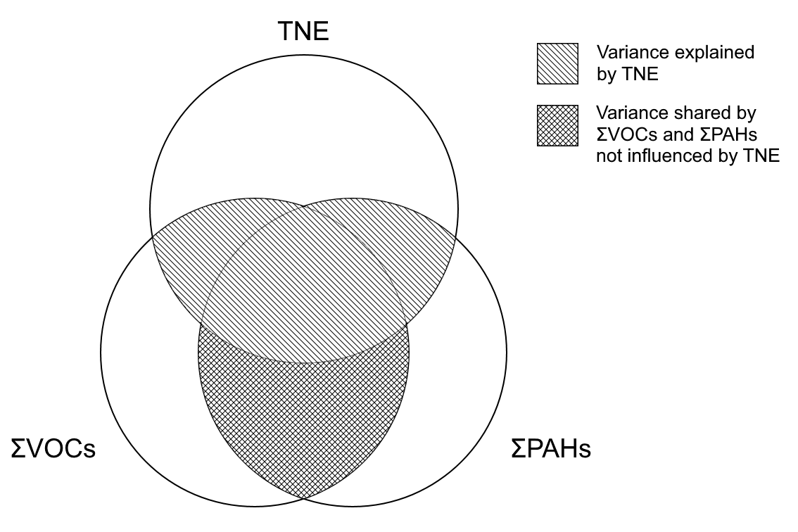
Figure S1 – Example of partial correlation between ΣPAHs and ΣVOCs controlled for TNE.

Table S6 – Effect sizes (partial R²) for three groups of volatile organic compounds (VOCs) on oxidative stress biomarkers.
Metabolite groups | Partial R² (8-oxodG) ¹ | Partial R² (8-isoprostane) ¹
Aldehydes ² | 0.05 | 0.09
Epoxides ³ | 0.05 | 0.07
Acrylamide and 1,3-butadiene ⁴ | 0.13 | 0.14
¹Partial R² were calculated by replacing the variable ΣVOCs by the variables Aldehydes, Epoxides or Others in the multiple linear regression models; ²Aldehydes was the logarithm sum of 3-HPMA and HPMMA; ³Epoxides was the logarithm sum of HEMA and 2-HPMA; ⁴Acrylamide and 1,3-butadiene was the logarithm sum of AAMA, GAMA, DHBMA, 1-/2-MHBMA, and 3-MHBMA.
Biomarkers: 8-oxo-7,8-dihydro-2’-deoxyguanosine (8-oxodG) and 8-iso-prostaglandin F2α (8-isoprostane), N-acetyl-S-(3,4-dihydroxybutyl)-L-cysteine (DHBMA), N-acetyl-S-(1-hydroxymethyl-2-propenyl)-L-cysteine (1-MHBMA), N-acetyl-S-(2-hydroxy-3-butenyl)-L-cysteine (2-MHBMA), N-acetyl-S-(4-hydroxy-2-buten-1-yl)-L-cysteine (3-MHBMA), N-acetyl-S-(3-hydroxypropyl)-L-cysteine (3-HPMA), N-acetyl-S-(2-carbamoylethyl)-L-cysteine (AAMA), N-acetyl-S-(2-carbamoyl-2-hydroxyethyl)-L-cysteine (GAMA), N-acetyl-S-(3-hydroxypropyl-1-methyl)-L-cysteine (HPMMA), N-acetyl-S-(2-hydroxyethyl)-L-cysteine (HEMA), N-acetyl-S-(2-hydroxypropyl)-L-cysteine (2-HPMA).

- Calculation of the % increase from multiple linear regression analysis

Let us define a = covariate concentration, b = covariate concentration + x % increase, c = outcome concentration, and d = outcome concentration + y % increase.
The y % increase in the outcome (associated to the x % increase in the covariate) is what we want to determine using multiple linear regression analysis (beta coefficients, β). We can write:
$$\log\left(d\right)=\log\left(c\right)+β*\left(\log\left(b\right)-\log\left(a\right)\right)$$
$$\log\left(d\right)-\log\left(c\right)=β*(\log\left(b\right)-\log\left(a\right))$$
$$\log\left(\frac{d}{c}\right)=β*log⁡(\frac{b}{a})$$
$$\frac{d}{c}=exp⁡(β*\log\left(\frac{b}{a}\right))$$
$$\frac{d}{c}= {exp⁡(\log\left(\frac{b}{a}\right))}^{β}$$
$$\frac{d}{c}={(\frac{b}{a})}^{β}$$
To obtain the % increase, we should transform the ratio of concentration in % increase:
$$x \% increase=\left(\frac{b}{a}-1\right)*100$$
$$y \% increase=\left(\frac{d}{c}-1\right)*100$$
If we transform our previous equation, we obtain:
$$\frac{y \% increase}{100}+1={\left(\frac{x \% increase}{100}+1\right)}^{β}$$
$$y \% increase= \left({\left(\frac{x \% increase}{100}+1\right)}^{β}-1\right)*100$$

